19th Century American Narratives
“Classic Stories and Timeless Novels”

Spring 2016
English 490/590: 19th Century American Literature
Tuesday/Thursday 2-3:15 P.M.

Dr. Richard Louth
rlouth@selu.edu

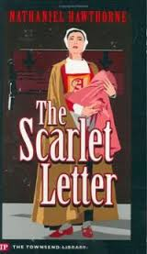

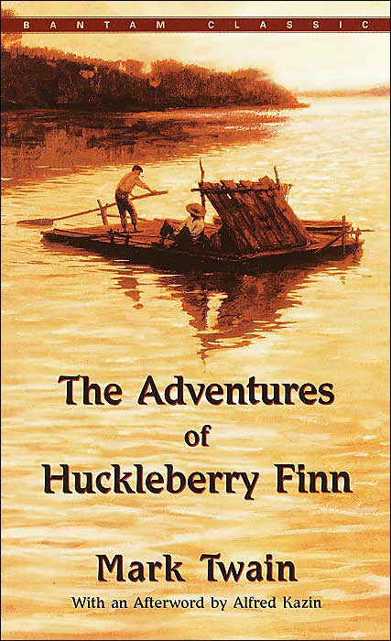

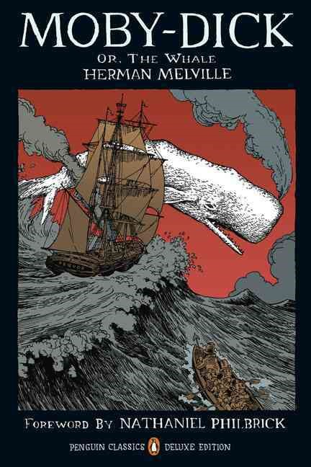

Short Fiction by:
Irving, Hawthorne, Melville
Poe, Longstreet, Thorpe, Lewis, Harris
Cable, Chopin, Twain
Crane, James, O.Henry

Tentative List of Novels:
A Scarlet Letter, Hawthorne (1850)
Moby Dick, Melville (1851)
The Adventures of Huckleberry Finn, Twain (1883)
Daisy Miller, James (1878)
The Red Badge of Courage, Crane (1895)
The Awakening, Chopin (1899)
Sister Carrie, Dreiser (1900)

