GENDER AND AMERICAN CINEMA
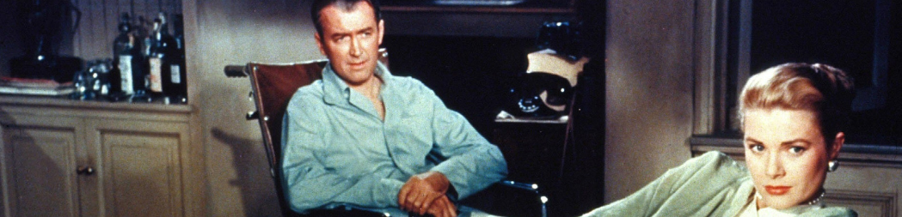

ENGL 429/527 | MW 3:30-4:45 | SPRING 2018
In this course, we will explore critical and theoretical approaches to questions of gender and film studies. Applying concepts from feminism, postfeminism, psychoanalysis, Marxism, and queer theory, we will investigate Hollywood’s gendered system of difference. We will begin the semester examining the Hollywood films that conform to Laura Mulvey’s foundational conception of the male gaze and then move on to look at how other films and directors challenge the male gaze through subtext, parody, and camp. Finally, we will end the semester by exploring contemporary trends in gender representation like the female action hero, the manic pixie dream girl, the comic book superhero, and the Bechdel test. Students will complete response papers, exams, a term paper, and a presentation. ENGL 429 is one of the courses required for the minor in Gender Studies.
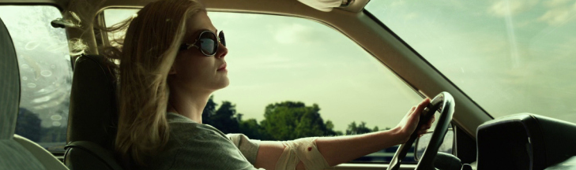

SCREENINGS
(500) Days of Summer (Webb, 2009) | Gone Girl (Fincher, 2014)
Bernie (Linklater, 2011) | Hanna (Wright, 2011)
The Bling Ring (Coppola, 2013) | Rear Window (Hitchcock, 1954)
Fatal Attraction (Lyne, 1987) | Scott Pilgrim vs The World (Wright, 2010)
The Girlfriend Experience (Soderbergh, 2009) | The Silence of the Lambs (Demme, 1991)
Gentlemen Prefer Blondes (Hawks, 1953) | The Wizard of Oz (Fleming, 1939)

FOR MORE INFORMATION, CONTACT JASON LANDRUM AT JASON.LANDRUM@SELU.EDU

