“When thou hast done, thou hast not done,
For I have more.”

John Donne, un-done,
All Donne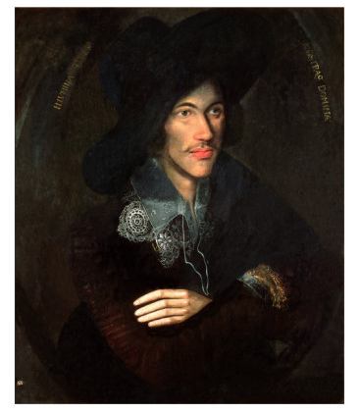

English 601
The Life and Writings of
John Donne
(1572-1631)

Spring 2018
2:00 p.m. TTh

Dr. Joan Faust (jfaust@selu.edu)

