Experiential Learning
at Southeastern

by
Ahmad Fayed, Ph.D.
Kellen Gilbert, Ph.D.
Denise Hart, MSN, RN, CWOCN
Danny Lee, PhD, APRN-BC, CNE
Ziba Rashidian, Ph.D.
Elizabeth Sanders, MLIS
Jayetta Slawson, Ph.D.
Cherissa Vitter, Ed.D.
Lu Yuan, Sc.D., CSP

Editorial Assistance:
Carl Monvoisin, GA

August 2020

‘

CONTENTS
CONTENTS 1
CHAPTER 1: EXPERIENTIAL LEARNING AT SOUTHEASTERN 2
CHAPTER 2: WHAT IS EXPERIENTIAL LEARNING? 3
CHAPTER 3: INTERNSHIPS 9
CHAPTER 4: SERVICE LEARNING AND CIVIC ENGAGEMENT 21
CHAPTER 5: STUDY ABROAD/STUDY AWAY 33
CHAPTER 6: EXPERIENTIAL LEARNING ONLINE 37
CHAPTER 7: TECHNOLOGY 45
CHAPTER 8: RISK ASSESSMENT IN EXPERIENTIAL LEARNING 52
CHAPTER 9: ASSESSMENT 59
CONCLUSIONS 73
APPENDICES 77

CHAPTER 1: EXPERIENTIAL LEARNING AT SOUTHEASTERN
Southeastern Louisiana University is deeply engaged in experiential learning as a learning method for students. In 2015, the University embarked on a five-year Real-World Ready (RWR) campaign dedicated to integrating experiential learning more fully into the academic curriculum. To that end, the campus initiated a Quality Enhancement Plan (QEP) to provide students new and enhanced experiences in environments authentic to their intended careers. As a result of that RWR campaign, every degree program at Southeastern established at least one officially designated Real-World Ready Course. These learning opportunities fall into categories as varied as internships, service learning, undergraduate research, civic engagement, study abroad/away, field experiences, creative activities, practice, hands-on learning, mentoring, leadership training, student teaching and apprenticeships.
The purpose of providing students an opportunity to “learn by doing” (as a supplement to course instruction) is to prepare students to be workforce ready upon graduation. However, before professors send students to complete learning experiences outside of the classroom, students need comprehensive orientations based on best practices and standards. Course assignments should align with outcomes that provide student opportunities to communicate effectively, reflect critically, and demonstrate commitment to quality work. Appropriate outside affiliation agreements should be executed. This handbook is a guide to assist faculty in designing academically-sound EL opportunities.

CHAPTER 2: WHAT IS EXPERIENTIAL LEARNING?
There are many definitions of experiential education, but one of the clearest and most encompassing comes from the Association of Experiential Education:
Experiential education is a teaching philosophy that informs many
methodologies in which educators purposefully engage with learners in
direct experience and focused reflection in order to increase knowledge,
develop skills, clarify values, and develop people's capacity to contribute
to their communities (https://www.aee.org/what-is-ee)
This definition highlights three fundamental aspects of experiential learning.
First, experiential learning can appear in many forms, depending on the design of courses. Instructors can tailor the form to align with their courses’ learning objectives and disciplines’ subject matter.
Second, experiential learning is more than just incorporating activities or hands on learning. Reflection is equally important to transforming an experience into a learning experience. Many instructors already use activities in their courses, but lack a reflective component that allows students to deepen their understanding and transfer their knowledge.
Third, regardless of its form, experiential learning requires active engagement from learners. Experiential learners do not passively absorb or repeat information. They explore, experiment, make decisions, analyze and reflect on experiences, and apply knowledge to future situations. Instructors thus act as partners and facilitators to learning.

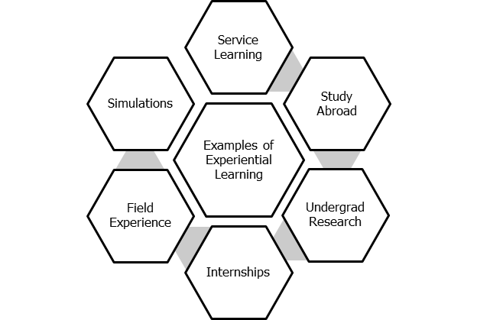

Figure 1 Examples of Experiential Learning
CC-BY-NC

Kolb’s Experiential Learning Theory

The cornerstone of contemporary experiential learning relates to David Kolb’s Experiential Learning Theory. Kolb (2015) argues that knowledge comes from “grasping” and “transforming” experience. “Grasping” refers to taking in information, while transforming refers to interpreting or acting on information.
His learning theory features two modes related to grasping experience (Concrete Experience, Abstract Conceptualization) and two modes related to transforming experience (Reflective Observation, Active Experimentation). In the process of learning, these modes act in a cycle “where the learner ‘touches all the bases’... in a recursive process that is sensitive to the learning situation and what is being learned” (51).

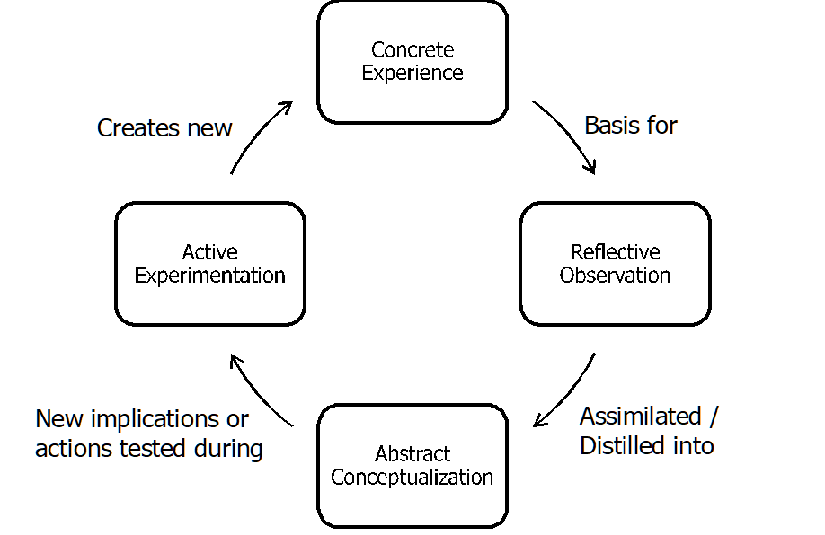

Figure 2 Kolb’s Experiential Learning Cycle Adapted from Kolb (2015) p.50-51.
CC-BY-NC

Most see the start of this cycle as Concrete Experience, which is logical given the title “experiential” learning. However, learners can enter into this process at any stage and even repeat the process several times in succession, depending on their learning situation.
National Society for Experiential Education’s Eight Principles
The National Society for Experiential Education (NSEE)’s Eight Principles of Good Practice for All Experiential Learning Activities is a useful tool to move beyond theory into practice. These guidelines outline conditions, steps, and actions experiential learning activities should have to serve learners and facilitators best.

Intention | All parties understand why experience chosen approach to learning to and to knowledge demonstrated, applied or resulting from it  Represents purposefulness that enables experience to become knowledge  Deeper than goals, objectives, and activities defining experience
Preparedness & Planning | Participants must enter experience with sufficient foundation to support success  Must adhere to identified intentions as goals, objectives, and activities are defined  Plan should include intentions, be referred to on regular basis, and be flexible to adaptations
Authenticity | Experience must have real world context and/or be useful and meaningful to applied setting or situation  Experience should be designed with those affected by it or who use it or in response to real situation
Reflection | Transforms simple experience into learning experience  Helps form knowledge through weighing outcomes against past learning and future implications  Integral to all phases of experiential learning  Essential tool for adjusting experience and measuring outcomes
Orientation & Training | All parties must know background information about each other and context/environment of experience as baseline  From baseline structured development should expand learner’s understanding of context and skill requirements of work
Monitoring & Continuous Improvement | All parties responsible for ensuring experience adapts as needed during process  Flexible feedback loop related to learning intentions and objectives essential  Formative evaluation tools
Assessment & Evaluation | Systematically document outcomes and processes in relation to initial intentions and outcomes  Assessment develops and refines learning goals and quality objectives identified during planning stages  Evaluation provides comprehensive data about experiential process and whether intentions met
Acknowledgement | Occurs throughout experience via reflecting and monitoring  Reporting, documenting, and sharing accomplishments  Culminating celebration of learning and impact can provide closure and sustainability

References

Association for Experiential Education. (n.d.) What is experiential education?. https://www.aee.org/what-is-ee

Kolb, D.A. (2015). Experiential learning: Experience as the source of learning and development. 2nd edition. Experience Based Learning, Inc. pp.50-51.

National Society for Experiential Education. (2013, December 9). Eight principles of good practice for all experiential learning activities. https://www.nsee.org/8-principles

Selected Resources

Experiential Learning LibGuide: http://selu.libguides.com/experientiallearning

Center for Faculty Excellence: http://www.southeastern.edu/admin/cfe/index.html

Experiential Learning Toolkit: https://www.eltoolkit.ca/

Dweck, C. S. (2017). Mindset. London: Robinson.

CHAPTER 3: INTERNSHIPS

Overview
Internships are one of the major activities identified by the National Society of Experiential Education (NSEE, 2020) for providing experiential experience to students. For successful experience with internships, the eight principles of experiential learning (i.e. Intention, Preparedness and Planning, Authenticity, Reflection, Orientation and Training, Monitoring and Continuous Improvement, Assessment and Evaluation, and Acknowledgement) should be followed.
This chapter introduces different aspects of internship and uses examples and case studies from Engineering Technology (ET) and Occupational Safety, Health & Environment (OSHE) programs. Topics covered include Importance of Internship, Internship Application Process, and Internship Assessment Process

Importance of IET Internship Classes
From educators’ point of view, internships are intended to provide students with the necessary experience, in an authentic environment, that complements the knowledge they receive during their course of study, with clear learning outcomes, and prepare them for a successful career as productive members of the community (Principles 1-3, NSEE, 2020). Internships have served as a prime example of cooperation between universities and private- and public- sector employers to provide a cooperative educational service to college students (McGlothlin Jr., 2013). These types of experiential learning allow students to apply the knowledge that they have learned in classes to solve problems in real-life situations (Fender and Watson, 2005). Employers also benefit from having qualified and well-prepared interns work for them, potentially leading to the improvement of their programs and businesses. With well-drafted guidelines and clear learning outcomes, internships can help complement the knowledge of graduating students and let them grow their practical skills and build pre-career experience.
In the Department of Engineering and Industrial Technology (IET), all of the three programs including Engineering Technology (ET), Industrial Technology (IT), and Occupational Safety, Health, and Environment (OSH&E) offer major-related internship classes. For ET and IT programs, internship classes are technical electives. For ET, a 400-level class can be used as a Technical Elective. For OSH&E, there are two internship classes, one at 200-level that can be used as a Professional Elective, and another at 300-level that is a required course and is selected as the one that demonstrates culminating experience according to the ABET (Accreditation Board for Engineering and Technology) requirements (ABET, 2020).
Because of the importance of these internship classes, quality assurance must be maintained to ensure the continuous improvement of the internship programs so that mutual benefits for students, employers, and universities can be maximized (Yuan and Bonnette, 2014).
In general, the IET internship classes are designed to provide an alternation of study on-campus and training off-campus as a superior form of education. Students receive on-the-job work experience with selected and approved industrial firms. For three hours credit a student must be employed a minimum of 20 hours per week during a regular semester and a minimum of 40 hours per week during the summer semester. The course objectives are to:
- Provide students with the opportunity to apply the knowledge gained in their coursework in an industrial environment.
- Provide students with an insight into the myriad of career opportunities available for IET graduates.
- Provide students with experiences in establishing objectives and formulating plans to achieve those objectives.
- Provide students with the opportunity to develop their leadership abilities in an industrial environment.
- Provide students with an objective evaluation of their work traits through an external review of their individual performance while working in an industrial environment.
Grades of the internship classes are assigned on a Pass/Fail basis only. Basis for assigning grades includes identification of student’s measurable learning objectives, two progress reports, daily log, time and wage report, employer’s evaluation of the student, student’s evaluation of the employer, and an executive summary.
Actual industrial experience is an integral part of the student’s formal education, where theory is blended with practice. In addition to their regular classroom and laboratory experiences, students gain valuable experiences by working in an industrial environment. It is expected that completing the industrial internship will help students attain the student outcomes and better prepare them to obtain the IET-related employment.

Internship Application Process
‘Preparedness and Planning’, ‘Orientation and Training’, ‘Reflection’, and ‘Monitoring and Continuous Improvement’ are four of the eight principles of Experiential Learning set by the NSEE and considered as important stages of any successful internship (Principles 2, 4, 5, 6, NSEE, 2020). With this in mind, educators should invest enough time to design different aspects and stages of the internship and prepare students to get the intended learning experience through a well-established guided process.
Students work with faculty members closely on exploring internship opportunities. However, it is students’ ultimate responsibility to secure an internship. The IET Department builds strong relationships with various industrial partners over the years. Many of the industrial partners have been hiring the IET students for internships and employment on a regular basis. The IET faculty members make recommendations when the internship opportunities arise if and as needed.
Students also participate in the University-wide Career Fair, and more importantly, the Tech-Connect Career Fair, which is exclusively designed for technology-related students since 2014, to navigate internship and employment opportunities. During the Tech-Connect Career Fairs, optional same-day and on-site interviews are conducted, where a number of students are able to secure the internship positions promptly.
To help industrial partners reach out to the IET students, the IET Department provides various information sessions during the regular class time or at the IET student organizations’ monthly meetings. A number of big companies, including Georgia-Pacific, ADM, Entergy, etc., have visited the campus and talked to students in recent years.
In addition, the IET faculty work with the industrial partners, especially those who have been hiring the IET students and graduates regularly, to set up both field trips for the current students and referral programs for the ongoing and upcoming opportunities. All of these efforts help ensure the continuity of the internship programs with the same companies and organizations.
The internships are normally performed within the State of Louisiana. However, students can work on an internship that is out of the State. In fact, a number of students, especially OSH&E majors, have been doing out-of-state internships over the last couple of years since more and more out-of-state companies have learned the quality of our OSH&E program and students.
The IET Department has developed the Internship Application Forms to help students apply for the internship classes. Originally, each program developed those forms independently. To standardize the process, the IET Department started to develop uniform forms in Fall 2016. These forms normally include the following:
- Form 101 – Application for Industrial Internship
- Form 102 – Industrial Internship Employer Agreement
- Form 103 – Student’s Measurable Learning Objectives
- Form 104 – Student’s Time Report
- Form 105 – Daily Activity Log
- Form 106 – Student’s Evaluation of Internship Employer
- Form 107 – Employer’s Evaluation of Internship Student
Depending on the needs, each program can add additional forms. For example, the ET program requires two additional forms containing internship agreement with host company and student, respectively.
The current application process is as follows:
- Students discuss the internship class (es) and application process with faculty advisors, especially when they are eligible for and interested in taking the internship class (es).
- Students explore and secure internship positions.
- Students work with the internship employer/supervisor and the internship coordinator on Forms 101, 102, and 103.
- The complete Forms 101, 102, and 103 are submitted to the IET Department Head and the College of Science and Technology Dean’s Office for review.
- When the forms are approved, students are assigned permission to enroll in the internship classes.
The internship objectives must be specific to the student’s job and must clearly describe what the student plans to accomplish during the work experience. Form 103 requires that students identify at least three measurable learning objectives, which are normally aligned with the program learning outcomes. They must be reviewed by the student’s immediate supervisor, who may suggest changes or additions. The objectives must be submitted during the internship application process and the internship coordinator must approve any changes to them during the first week of the semester.

Internship Assessment Process
Students who are enrolled in the internship class (es) are required to work on a number of forms (e.g., Forms 103 ~ 107) and reports throughout the semester. The instructors of the internship class (es) explain the specific requirements in the course syllabi. In general, the following items are included:
- Daily/Weekly Activity Logs: Throughout the semester, students must maintain a Daily Activity Log (Form 105) of all work-related activities. Entries must be made every day. Students are required to write a short paragraph that details their daily accomplishments. These detailed entries also help students work on their progress reports and final executive summary. Students are normally required to post the week’s daily log sheet every Wednesday for the prior week’s activities. In most cases, students’ daily activities should be related to the stated objectives for the course from Form 103. There is a column on Form 105 where students can post the number of objectives from Form 103 that their activities are related to.
- Progress Reports and Executive Summary: All students are required to submit three written papers over the course of the semester. These papers are a narrative report on their work experiences and how they relate to their course work at Southeastern and any new learning experiences.
- Time Report: During the last week of classes, students must complete and submit the Time Report (Form 104) that verifies the hourly requirement for the semester.
- Employer’s Evaluations of Internship Student: At the end of the semester, the student’s supervisor must evaluate the extent to which the student accomplished each of the objectives that were described in Form 103 by assigning a percentage figure from 0% to 100% in the column to the right of the objective. In addition, the internship immediate supervisor must complete Form 107 by evaluating the student objectively, comparing him/her with other students of comparable academic level, with other personnel assigned the same or similarly classified jobs, or with individual standards.
- Student’s Evaluation of Internship Supervisor: At the end of the semester, the internship students are required to complete Form 106 by providing an overall rating of the internship employer and work experience, addressing the relatedness of the internship to their course work, and recommending changes and revisions to both the internship experience and internship class requirements, etc.
As a Real-World Ready component to examine the students’ reflection of their internship experience, an additional item called Student’s Presentation of Internship is added into the class requirements. This item does not have a specific structure; rather, the instructor of the internship class with the RWR designation plans to do one or more of the following activities with the internship student (and their internship supervisor if and as appropriate) at the end of the semester to know more and better about their internship:
- Visit the internship (and talk about the internship with the internship supervisor if possible).
- Discuss the internship with the students in school or another place as appropriate.
- Require the students to do a presentation (can be informal) of their internship experience in school or at their internship place.
To help the internship, students work on various forms/reports and meet the class requirements, the instructors of the internship class (es) also provide guidance and tips throughout the semester. For example, the following requirements and tips for Form 105 are provided for OSHE 391 in the beginning of Fall 2019:
- Write a short paragraph that details the daily accomplishments.
- If there are any significant issues that were discussed or things that were learned during the daily routine, students may also include that information in the form. The information will help students work on the progress reports and final executive summary as well.
- In most cases, the daily activities should be related to the stated objectives for the course from Form 103 that students submitted during the internship application process. There is a column on Form 105 where students post the number of objectives from Form 103 that the activities are related to. <If you do not have a copy of Form 103, please visit the IET Department Office, ask for your folder, and request a copy of your Form 103.>
- Students are expected to work a minimum of 20 hours every week in Fall 2019 in order to earn three credit hours for the class. <If you are unable to work 20 hours in a given week, please specify the reason and add a make-up plan as appropriate in Form 105.>
The following tips for Progress Report #1 are provided:
- Describe your internship experiences, especially the most important things learned and the challenges encountered, in the first month of the semester.
- Relate the experiences to the OSHE courses that you have taken and/or are taking this semester.
- Reflect on the relationships between the experiences and the measurable learning objectives for the internship.

The basis for assigning grades is explained in the internship course syllabi. Since the official grade assigned to this course will be a “P” for Pass or an “F” for Fail, the IET Department grading scale will only be used in assigning grades to assignments in order to determine if a student passes or fails the course. The minimum score to receive a Pass grade is 77%, which is equivalent to a C grade if letter grades were to be used.

References

Accreditation Board for Engineering and Technology (ABET). 2020. Criteria for Accrediting Applied and Natural Science Programs, 2020-2021 (retrieved April 19, 2020) (https://www.abet.org/accreditation/accreditation-criteria/criteria-for-accrediting-applied-and-natural-science-programs-2020-2021/).

Fender, D. L. and Watson, L.E. 2005. OSH Internships: One Program’s Perspective on Benefits for Students, Employers and Universities. Professional Safety. Apr.: 36-40.

McGlothlin Jr., C.W. 2003. OS&H Internships: What Graduates Are Saying about Their Experience. Professional Safety. Jun.: 41-50.

National Society of Experiential Education (NSEE). 2020. Eight Principles of Good Practice for All Experiential Learning Activities (retrieved Feb 19, 2020) (https://www.nsee.org/8-principles)

Yuan L. and Bonnette J. 2014. Value of Industrial Internship in the Occupational Safety, Health, and Environment Program. The American Society of Safety Professionals’ Professional Development Conference & Exposition 2014 (Safety 2014), Orlando, FL.

CHAPTER 4: SERVICE LEARNING AND CIVIC ENGAGEMENT
Service Learning is a form of experiential learning that integrates the academic component of a course with relevant service projects or work and requires critical reflection throughout the process on the part of the student. Service-learning is different from an internship because where an internship is focused primarily on providing enhanced and hands-on learning in a real world setting for the student, service-learning strives to provide both a deepening of student knowledge through real world experiences while at the same time providing a tangible benefit to the community or organization, advancing its particular goals and objectives. Service-learning, then, is about reciprocal benefits: the student gains through the process of bringing classroom knowledge into the field and putting it to “work” in the world, while the organization or community gains through the commitment and participation of the students. The process of critical reflection completes the circle, since that is where the student brings the knowledge or understanding of the field gained by “doing” back to the classroom. According to the Corporation for National and Community Service, “Service-Learning is a teaching and learning strategy that integrates meaningful community service with instruction and reflection to enrich the learning experience, teach civic responsibility and strengthen communities” (qtd. In Duncan and Taylor, 2015, p. 2).
In the 1990s, a meeting of service-learning educators and scholars generated a research program, which enunciated the “Wingspread Principles,” outlining best practices for combining service and learning in higher education. While there has been some talk among practitioners and scholars about possible revisions to these principles in order to more directly articulate the way service-learning programs and projects enhance democratic citizenship and civic engagement, the Wingspread principles remain foundational for service-learning in today’s institutions of higher education.
Wingspread Principles of Good Practice in Combining Service and Learning
1. Engages people in responsible and challenging actions for the common good.
2. Provides structured opportunities for people to reflect critically on their service experience.
3. Articulates clear service and learning goals for everyone involved.
4. Allows for those in need to define those needs.
5. Clarifies the responsibilities of each person and organization involved.
6. Matches service providers and service needs through a process that recognizes changing circumstances.
7. Expects genuine, active, and sustained organizational commitment.
8. Includes training, supervision, monitoring, support, recognition, and evaluation to meet service and learning goals.
9. Ensures that the time commitment for service and learning is flexible, appropriate, and in the best interest of all involved.
10. Is committed to program participation by and with diverse populations.
(Porter-Honnet and Poulsen, 1990, adapted from p. 40.)

Degrees of Integration of Service-Learning Components
While most scholars and practitioners believe successful service-learning courses integrate service learning as the predominant pedagogy of a given course, there are at least three models for the inclusion of service learning in a course. A first possibility is, in consultation with the community organization, to devise a project for students that will require a few hours to a few days to complete. This involves a short-term project-based service-learning “assignment” in a class with broader learning objectives. Normally, a minimum of 15 hours of work on the project with the organization is necessary for this service-learning option to provide the reciprocal benefits to the students and the organization. A second possible form that service-learning can take is a short-term placement with an organization or community group; in this case, the student works to assist the organization with an ongoing project or program, rather than helping to develop a new project. The preferred, though not always feasible, service-learning option involves an immersive engagement with the organization over the course of the semester so that the student becomes part of the community organization and is much more fully integrated as a participant in its overall goals, culture, and vision. The decision on the degree to which the service-learning component is integrated into a course depends on several factors, one of which is the set of learning outcomes the course is meant to achieve, but the other and equally significant elements are the needs and goals of the community organization with which you hope to work. Depending on the organization’s finances and the human resources it has available to work with students, some organizations might benefit more from a short-term service-learning project rather than the longer term, more intensive student engagement.
Identifying and Developing Community Partners
Southeastern’s Experiential Learning initiative has encouraged a more decentralized form of community outreach and partnering. Individual departments and faculty members, using their disciplinary knowledge and networking with community organizations whose interests converge with their academic fields, generally do the work of identifying community partners and exploring the possible mutual benefits of a service-learning course or program for their students and the community organization. In general, faculty reaching out to community organizations need to ensure that it is the organization that sets the parameters and goals of the project and not the academic needs of the students. The service-learning engagement of the students by definition should provide a benefit to the community or the organization and this needs to be a benefit that the organization actually desires and is in line with its mission, objectives, and capacities. In addition, the community organization, often underfunded and understaffed, must be assured that entering into the service-learning partnership will not create a greater burden on its resources. The balancing act of service-learning requires that the faculty member presents the course’s learning outcomes to the organization to ensure that they are in line with the organization’s own goals and so that the members of the organization working with the students know the kinds of learning experiences that are structuring the course. Before launching the service-learning course, consolidate your agreement with the organization by developing a written agreement (sometimes referred to as an affiliation agreement, but also more formalized as a memorandum of understanding) that clearly outlines the parties involved (the organization and its representative, the class and its faculty member), the term of the project, the work to be accomplished, and any requirements of the organization (such as participation in a final meeting with the class to discuss the experience of their involvement with the organization and the organization’s response to their participation). If students are working on site, a hold harmless clause should be appended to the MOU to protect the students, the University, and the community partner. (See Appendix A for an example of an Affiliation Agreement.)
Designing a Service-Learning Course
One of the most difficult aspects of designing a service-learning course is striking the balance between experiential and academic learning and ultimately, trying to see these two forms of learning as mutually reinforcing and integrative, rather than dichotomous. The struggle is to escape the “theory”-“practice” perspectives on what happens “in the world” and what happens “in the classroom.” A first offering of a service-learning class can often tilt either toward a strong emphasis on academic and classroom learning, with the service-learning component serving as a kind of “illustration” or example, OR go the other way, and focus so much on the service-learning component that the academic focus, the development of the knowledge base, is short-changed. Finding the balance point may well take more than one attempt teaching the course to perfect. However, Barbara Jacoby in her book, Service-Learning Essentials, provides a list of issues to consider when designing a service-learning course that if fully utilized, help to minimize the dangers of experience without knowledge or knowledge without experience!
Jacoby’s steps for designing a service-learning course include the following:
1. State desired learning outcomes: this will enable students to understand why the service-learning component is an essential element of the course. And clearly identify those that will best be served by service learning.
2. Envision service experience that will serve as primary course text. Which organization allows students to do what sorts of projects/activities will best enable students to achieve your stated learning outcomes?
3. Select other course content and pedagogies: what discipline-specific knowledge, theory, methods do the students need to master in order to engage fully with the community-based project?
4. Seek potential community partners: weigh which organizations in the community would most benefit from students engaging in the kinds of projects and activities you envision as satisfying your learning objectives. When you approach the community partner, you should share your draft syllabus and desired learning outcomes so that you can be sure that the partnership will benefit the organization and provide students with the desired learning experience.
5. Build critical reflection into the structure of your course.
6. Be sure to provide a forum that incorporates the community organization’s response to and assessment of the final project and/or the students’ service-learning contribution.
7. Plan a celebration and final shared reflection including students, faculty, and community participants.
(Jacoby, 1990, adapted from pp. 100-102).
Jacoby’s list touches on a crucial element in all service-learning courses: critical reflection. On some level, the learning in “service-learning” cannot happen without critical reflection and even more crucially critical reflection is what ultimately serves as the bridge between disciplinary knowledge and practice. Cress, Collier and Retenaur (2005) discuss the practice and importance of critical reflection in service learning pedagogy this way: “Building upon ideas originally developed by the pragmatist philosopher John Dewey (1933), within the context of service-learning classes we define “reflection” as “a person’s intentional and systematic consideration of an experience, along with how that person and others are connected to that experience, framed in terms of particular course content and learning objectives” (p. 84). Without critical reflection, students may well “have the experience, but miss the meaning.” In service-learning pedagogy, reflection functions as the infrastructure of the course, and needs to be an ongoing, cumulative process, that leads, by the end of the course, to the consolidation of insights arrived at through the combination of disciplinary learning and experiential immersion. In order to incorporate reflection as an ongoing element of the course, it is useful to remember that critical reflection does not always have to entail, though it most often does, WRITING. Reflection can be designed into a course in the form of directed discussions, presentations, interviews, and even storytelling. Writing is the medium most often used in a college-level course to promote critical reflection since it requires the inventory and organization of thoughts and the production of a permanent document of the student’s learning at a given moment in the service-learning experience. For more on critical reflection across media, see Jacoby, 1990, Ch. 2.
Another concern faculty confront in designing a service-learning course is that they may sacrifice the academic rigor to experiential insight. In general, the advice of the experts is to build a firm foundation for your students in terms of the academic element of the class. They need knowledge and a solid orientation to the issues the organization is tackling before they can be full participants in the organization’s projects and culture. The goal is a process of knowledge-into-practice and so careful preparation of students is the sine qua non of experiential or service learning. But as Jacoby notes above, the community experience is itself an “assigned text”—and students should approach their work with the organization with the same rigor and attention, the same critical and analytic skills that they apply to course assignments and readings. Carefully articulated learning objectives can bring this point home to students and address another common problem in service-learning courses—students’ shirking of their responsibilities toward the organization.
At Southeastern, another key consideration in the design of your service-learning course is the University’s Course Time Investment Policy. Since service-learning courses are distinguished from internships or field experiences, they are most often designated as “lecture” courses. As of Spring 2020, a three-credit hour lecture course involves 112.5 hours of time investment on the part of the students; this includes 37.5 hours of in-class time (including exams) and 75 hours of out-of-class work (including reading materials, writing papers, etc.). The service-learning component of the course would draw on these 75 hours of out-of-class work on the part of the students, though, obviously conversations with community partners could take place in the classroom. A general rule of thumb as you consider the time required for students to engage with the different learning components of your course is that a service-learning experience should involve a minimum of 15 hours of direct student participation with the organization. Most service-learning projects and placements will require more than 15 hours to complete.
Some Tips on Things to Include in Your Syllabus
Many students entering your service-learning course will not know what a service-learning course is. Your syllabus needs to describe the philosophical and pedagogical principles that underwrite the service-learning approach. The syllabus will need to explain how the service-learning element of the class is integrated with the course learning outcomes and what the expectations are for student participation, commitment, and comportment. Be sure to emphasize the necessity of professionalism in student behavior when working in the community as well as in interactions with classmates as co-workers on the project. Describe what professionalism entails in these contexts. Your syllabus will need to explain the specific service-learning experience of the course, the expectations in terms of time commitment, duties and responsibilities, transportation, scheduling and communication with the organization contact person, team-members, and the instructor. Finally, your syllabus should provide a detailed introduction to the key pedagogical tool of service learning: critical reflection. (For an example of a service-learning course syllabus working with an NGO, see Appendix B).
The Student Contract
Because the success or failure of the service-learning project can have real consequences for the community organization, it is imperative to instill students with an ethos of professionalism. They need to be motivated to show up, to be prepared, to function in a professional manner, and to be committed to the goals of the project and serving the needs of the organization. Of course, the best way to ensure this kind of student commitment is to make them care about the issue that is being addressed through the discipline-specific material you present as well as what they can learn from the community organization. It doesn’t hurt to remind them that not only will their learning be directly proportional to their engagement, but that unlike writing a term paper or taking a test, their work in the service-learning project will result in a direct, observable change in the community being served by the project. A specific contract between the student and the teacher, which outlines expectations, time frames, and expected actions and/or products, is one way to start this process because it shifts their understanding of their participation from “a class assignment” to “my contribution to addressing a real issue in the real world that affects real people.”
Things to include in the contract:
1. Student Name
2. Acknowledgement that the student is aware s/he is enrolled in a service-learning course that requires participation in a community-based learning experience.
3. Acknowledge of the specific kinds of assignments/tasks that will be required to satisfy the service-learning component of the course—including critical reflections.
4. Agreement to comport him- or herself with professionalism as a representative of the university working in the community. The contract can specify what will demonstrate this professionalism (timeliness, consistent participation, engagement, etc.).
5. A hold-harmless clause.
6. Signatures of student and faculty member.
7. Date.
(For an example of a student contract, see Appendix C.)
Final Thoughts
As we go into the 2020s, Generation Z. is replacing GenXers. According to the National Association of College Admission Counseling, this new generation has some very distinct expectations about their college experiences. While their pragmatism means they want to have skill-based education and closer integration of their education with industries and employers, a member of the association notes, “Generation Z feels passionate about making their world a better place,” said Dayna Bradstreet, assistant director of admission at Simmons College in Boston. “I am constantly impressed by the changes applicants have brought about in their high school communities” (https://www.nacacnet.org/news--publications/journal-of-college-admission/instant-generation/). This suggests that this generation of students will enter our service-learning classes with a great willingness to engage in projects addressing problems in their communities.
Still, as anyone who has taught a service-learning class will tell you, you need to be prepared to run into problems; after all there might suddenly be a pandemic where on-site meetings and work become impossible, where face-to-face guided reflection discussions become impractical because not all students have equal access to technology, and where university resources are suddenly unavailable, locked away behind shuttered doors. Even if no worldwide crisis suddenly crops up to spoil your beautifully planned and organized course, your community partner may suddenly confront new challenges or opportunities and this too may require some quick reworking of the course plan or project. Of course, most times (fingers crossed), your course won’t run into such problems, but it is best to be ready to pivot at a moment’s notice, to have Plan B at the ready in case the unanticipated happens.

References

Cress, C. M., Collier, P. J., & Reitenauer, V. L. (2005). Learning Through Serving : A Student Guidebook for Service-learning Across the Disciplines: Vol. 1st ed. Stylus Publishing.

Duncan J. and Taylor, T.B. (2015). Service-learning in the community: The cultural implications of positive change. Retrieved from http:ebookcentral.proquest.com.

Jacoby, Barbara (2015). Service-learning essentials: Questions, answers, and lessons learned. San Francisco: Jossey-Bass.

Porter-Honnet, E., & Poulson, S.J. (1990). Principles of good practice in combining service and learning. In J.C. Kendall (Ed.), Combining Service and learning: a Resource Book for Community and Public Service (Vol. 10. Raleigh, NC: National Society for Experiential Education.

CHAPTER 5: STUDY ABROAD/STUDY AWAY
Study Abroad and Study Away programs are experiential by nature. Planning for, traveling, and experiencing another part of the country or world make for an excellent opportunity for students to connect authentic world experience with discipline-specific academic content. Study abroad and study away experiences also help meet Southeastern’s Vision 2025 strategic priority of engaging “diverse population of learners with powerful experiences.” http://www.southeastern.edu/admin/ir/planning/assets/vision_2025.pdf
Course work with intentional experiential learning can be transformative; though to be effective must be participatory and involve critical reflective thinking, creative questioning and discourse (Mezirow, 1997). Having the skills to work and thrive as a global citizen requires an awareness and understanding of other ways of life, or intercultural competency. However, just traveling to another country or culture does not guarantee a student’s intercultural competency will increase (Parras & Mitchell, 2017). Careful development of support before, during and after the course may enable students to integrate new experiences and fulfill learning outcomes of the course. This means pre-course, pre-travel meetings that provide information about the destination: geography, weather and climate, language basics, typical foods and beverages, money issues, use of electronics, health and safety considerations, rules of etiquette, and so forth is necessary. Also, learning about concepts such as culture shock, ethnocentrism, and intercultural competence, though does not necessarily translate into practice while abroad, may help students know how to react when experiencing unfamiliar or challenging situations (Parras & Mitchell, 2017). Planning for on-going discussions and support while in the country may help turn situations into learning opportunities for students, thus boosting the experiential component and increasing the students’ intercultural competency. Post-trip reflection will help students process “disorienting dilemmas” or problems a student encounters, in this case during the study abroad experience, which sparks curiosity and levels of questioning (Mezirow, 1997).
Experiential Learning Component

While simply being another country or culture is experiential learning, the authentic experience will be intentional, directly related to the academic focus, well planned and involve reflection (National Society for Experiential Education, 2013). Experiential learning should be incorporated as the other aspects of the study abroad course are developed instead of considering as “add ons.”
Short-term programs that involve travel to a single location a specific experiential learning opportunity for the class may be a group service-learning project. For example, the students in the Environmental Sociology Study Away program in Zion National Park spend a day working on trail development with park rangers. For long-term programs, individually designed service learning or community engagement projects or internships may be appropriate. During a two-month Spanish language Study Abroad program in Mexico, students partnered with area schools and provided tutoring sessions twice a week for local high school students learning English. These service-learning experiences, either one-time or recurring, are authentic learning opportunities directly related to the course work.
The experience does not end with the service or other activity. Reflection, pre-service, during and post-service, is an essential part of experiential learning. This may take the form of journal writing assignments that allow the students to process the experience and connect it to course. Other types of reflection include having guided discussions, creating a portfolio illustrating the service, or developing a presentation about the experience.
Other Considerations
Most faculty-led study abroad or study away programs at Southeastern are offered during the summer or during interim periods and are three to six credit hours, or the equivalent of one or two courses. The course time investment for students in a three-hour credit course must be at least 2,250 minutes (Office of Study Abroad).
As with all types of learning activities, faculty need to be aware of potential risks. Please refer to the Office of Study Abroad’s risk management guide for health and safety protocols.
Various scholarships are available for students, including the Student Government Association’s travel grants, and departmental grants. Encourage students to consult with the Office of Study Abroad and their home departments for more information and applications.

References

Mezirow, J. (1997). Transformative learning: Theory to practice. New Directions for Adult & Continuing Education, 1997(74), 5. https://doi-org.ezproxy.selu.edu/10.1002/ace.7401

National Society for Experiential Education. (2013, December 9). Eight principles of good practice for all experiential learning activities. https://www.nsee.org/8-principles

Paras, A., & Mitchell, L. (2017). Assessing Intercultural Competence in Experiential Learning Abroad: Lessons for Educators. Experiential Learning & Teaching in Higher Education (ELTHE): A Journal for Engaged Educators, 1(1), 45-64.

Selected Resources at Southeastern:

International Initiatives- Study Abroad
https://www.southeastern.edu/acad_research/programs/ii/students/index.html

Center for Faculty Excellence
https://www.southeastern.edu/admin/cfe/index.html

Other University Programs:

University of Tennessee Knoxville
https://programsabroad.utk.edu/faculty-advisors/program-development/

NAFSA: Association of International Educators
https://www.nafsa.org/about/about-international-education

For passport information, country information, travel alerts:

United States Department of State Bureau of Consular Affairs
https://travel.state.gov/content/travel.html

CHAPTER 6: EXPERIENTIAL LEARNING ONLINE
Technology should be a tool, not the driving force. As educators move courses to online experiences, they must examine if technology is influencing the essence of the course. Technology will influence the structure, but the foundation of the course should remain intact. In addition to consistent learning outcomes, virtual learning environments allow unique opportunities to employ differentiation through experiential learning techniques.
John Dewey theorized that learning takes place in a social context (Dewey, 1938). How are we defining a social context? At one time, it revolved around dancing, but young learners were raised within a social media culture. To keep this idea in a frame of reference, let us remember a few socially significant events. The Apple iPhone was introduced in 2007, and Barack Obama was the first presidential candidate to use a social media campaign. Students graduating high school in 2020 were about five-years old during this time; thus, the way they define social context is based on their own experience. Jean Paiget theorized that humans have the ability to associate experience, which is especially effective when relating prior knowledge (Mcloed, 2018). Students going to university do not vividly remember a time without social media, and this is their experience.
The priority for course design is to create a learning environment where students can gain understanding through experiences, regardless of the delivery. The Association for Experiential Education (AEE) defines experiential education as a “teaching philosophy that informs many methodologies in which educators purposefully engage with learners in direct experience and focused reflection in order to increase knowledge, develop skills, clarify values, and develop people's capacity to contribute to their communities” (Miano). Experiential learning must be facilitated by creating a learning environment. To that end, it is beneficial to use technology that saves time rather than technology that takes time (Caulfield, 2011). The focus should always remain on the learning outcomes. It is also important to establish the tone of the virtual learning environment including a netiquette policy and norms for synchronous meetings.
Roberts (2016) describes experiential education as an ecosystem with four major categories: Project-based learning, Active learning, Community-based learning, and Integrative learning. Each category has descriptive indicators as shown in the graphic below. These categories may be realized in the online environment through course design. There are several decisions you will need to make when designing your course. Will you use one platform or a combination of platforms, such as Moodle, Canvass, Blackboard, Google Classroom, etc.? What additional platform might you incorporate for communication and group work, like Google Suite, Zoom, or Microsoft HD? Are you comfortable with making videos to convey content and/or viewing student videos as assessment practices in addition to written and verbal feedback? Are you able to honor your course outcomes without infringing excess work on your students or yourself (Caulfield, 2011)?
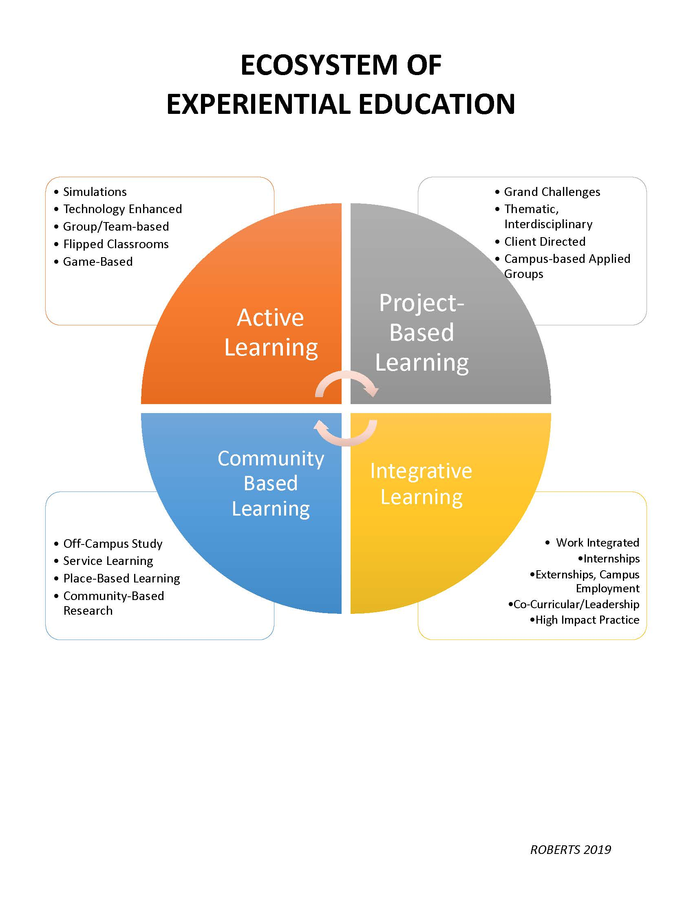

Not all courses lend themselves to being divided into learning categories and may benefit from impact experiences. High impact experiences align with the descriptors within Robert’s learning categories, such as:
- Learning Communities
- Collaborative Assignments and Projects
- Undergraduate Research
- Diversity/Global Learning
- ePortfolios
- Service Learning, Community-Based Learning
- Internships
- Capstone Courses and Projects (Kuh, 2008).
Ritchhart, Church and Morrison (2011) warn against assigning activities for the sake of activities.
In the often misunderstood notion of experiential or inquiry-based learning, students are sometimes provided with lots of activities. Again, if designed well some of these activities can lead to understanding, but too often the thinking that is required to turn activity into learning is left to chance (p.9).
The task is to assess student understanding through performance. How do you know if students learned and at what level of understanding? Wiggins and McTighe suggest that authentic assessments replicate real-life situations and allow for feedback and refinement (Wiggins & McTighe, 2008). One of the assessment challenges in the virtual environments is assessment differentiation between informal and summative assessments. Informal assessment may be accomplished through small assignments, journaling, reflecting, and a myriad of other options. In virtual classrooms, the instructor is not always able to see students' reactions to new content. In a class setting, instructors constantly informally assess student understanding through observation and questioning. Informal assessments are used to inform teaching. This type of assessment may be used in the virtual classroom in a variety of ways depending on your subject area.
Material chunking is an example of internal assessment to provide feedback to students before completing summative assessments. When it comes to informing teaching at the beginning of a unit, there are also techniques that can be used. See - think - wonder is a strategy that is often used in an elementary classroom but also has merit in andragogy. In a classroom, the teacher would show a visual and ask the students to observe evidence, followed by what they think may be happening and any wonderings they have. This technique is used with adults in the university experience as well as professional development. Students may be shown a picture, a graph, data, etc. and reflect on the same questions. This will allow the instructor to visualize the thinking of his or her students. In an online classroom, the use of Google Docs is valuable because students can see what the others are thinking. This can also be used in the Discussion Forum and Journaling. The purpose remains for the instructor to gain insight into student understanding informally before completing a summative assessment of content.
When choosing a summative assessment, instructors want to utilize strategies that lend themselves to the virtual experience. Rubrics may be used in assessing experiential learning because of the variety of answers. Rubrics promote consistency in grading while allowing for differentiation. Carnegie Mellon University concisely outlines the significance of an assessment rubric:
Grading according to an explicit and descriptive set of criteria that is designed to reflect the weighted importance of the objectives of the assignment helps ensure that the instructor’s grading standards don’t change over time...grading rubrics are invaluable in large courses that have multiple graders (other instructors, teaching assistants, etc.) because they can help ensure consistency across graders and reduce the systematic bias that can be introduced between graders.
Instructors are familiar with designing rubrics for research and essay assessments, but rubrics may also be used for projects and presentations. See the example below of a Discussion Performance rubric, which has been annotated to illustrate the virtual learning environment.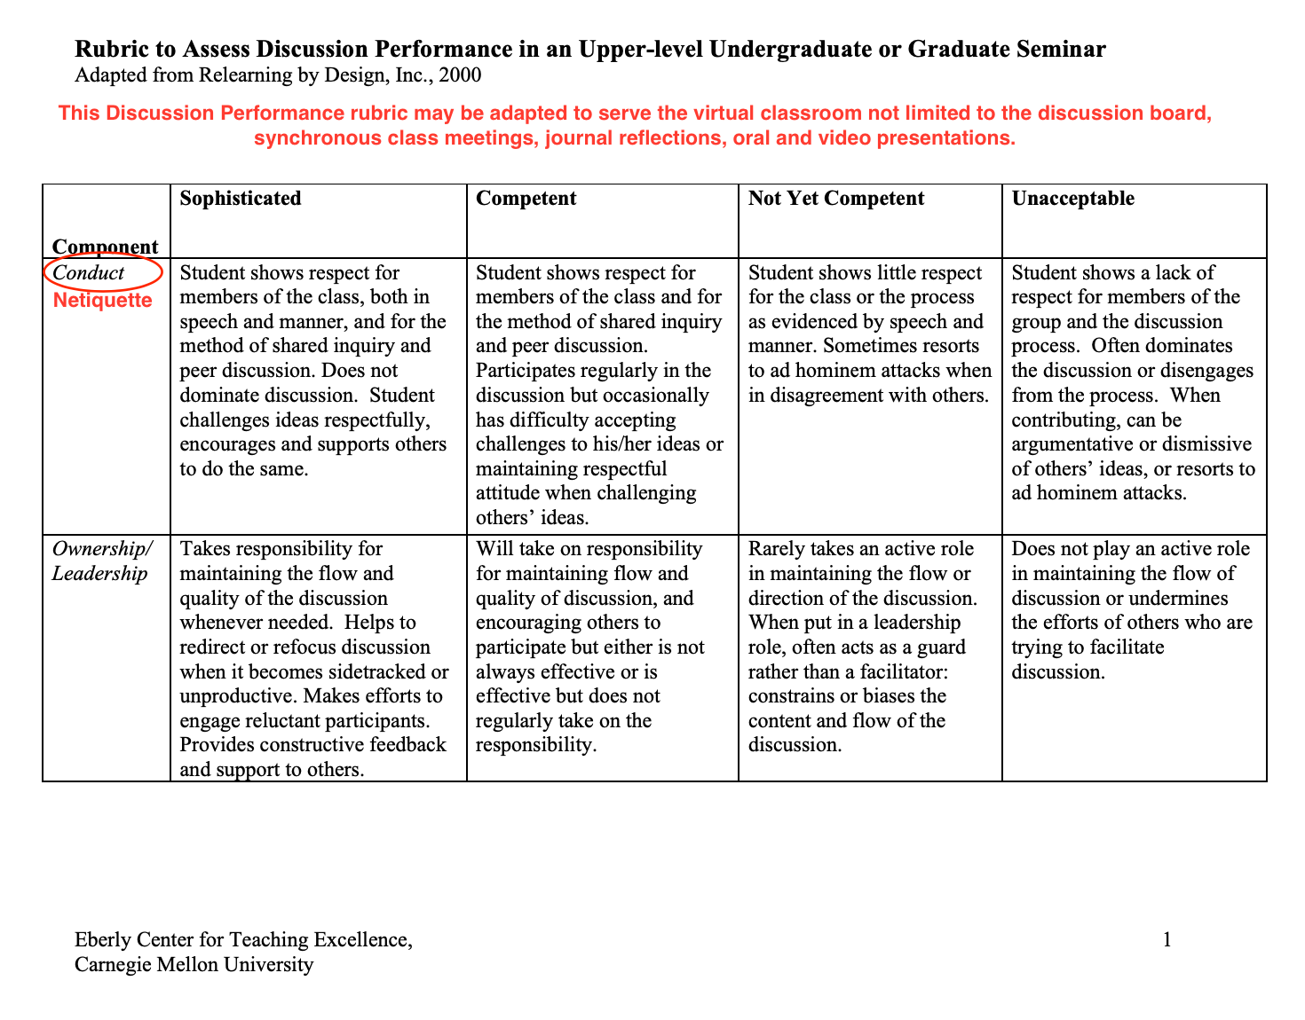

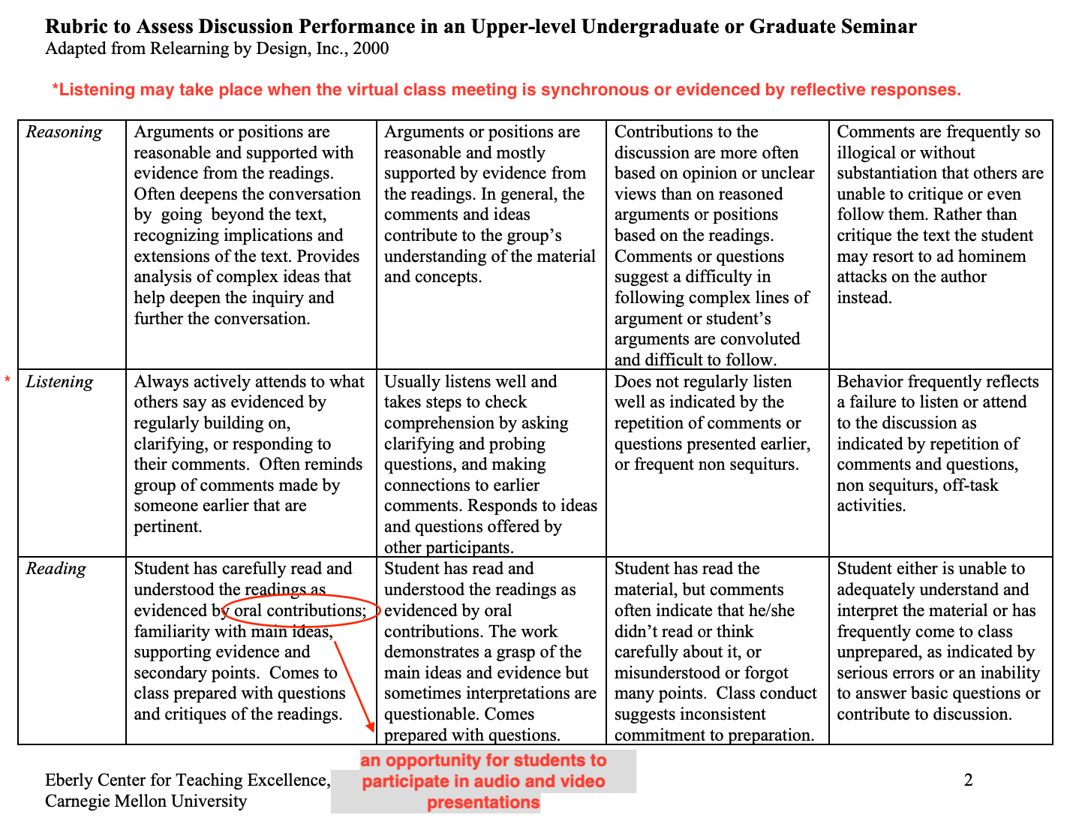

What are your next steps? Professional Development. Meet with an instructional designer to incorporate your content into an online learning experience. Consider professional development to enhance effective teaching and learning skills. University instructors are experts in content areas, but we can always improve in pedagogy and andragogy techniques to communicate effectively with our students. When learning environments are created, students can gain understanding through virtual social context using experiential learning techniques.

References

Carnegie Mellon University. (n.d.). Rubrics - Eberly Center - Carnegie Mellon University.
Retrieved from https://www.cmu.edu/teaching/designteach/teach/rubrics.html

Caulfield, J. (2011). How to design and teach a hybrid course: achieving
student-centered learning through blended classroom, online, and experiential
activities. Sterling, Virg.: Stylus Pub.

Danielson, C. F. (2016). Talk about teaching!: leading professional conversations.
Thousand Oaks, CA: Corwin.

Dewey, J. Experience and Education. Touchstone, 1938.

Kuh, G.D. (2008). High-impact educational practices: What they are, who has access to
them, and why they matter. Washington, DC” Association of American Colleges and Universities.

McCuen@aacu.org. (2018, March 9). High-Impact Practices. Retrieved from
https://www.aacu.org/resources/high-impact-practices

Mcleod, Saul. “Jean Piaget's Theory of Cognitive Development.” Simply Psychology,
Simply Psychology, 6 June 2018, www.simplypsychology.org/piaget.html.

Miano, A. (n.d.). What is EE? Retrieved from https://www.aee.org/what-is-ee

Perkins, D. N. (1995). Smart schools: better thinking and learning for every child. New
York: Free Press.

Ritchhart, R., Church, M., & Morrison, K. (2011). Making thinking visible: how to
promote engagement, understanding, and independence for all learners. San Francisco, CA: Jossey-Bass.

Roberts, J. W. (2016). Experiential education in the college context: what it is, how it works, and why it matters. New York: Routledge.

Wiggins, G. P., & McTighe, J. (2008). Understanding by design. Alexandria, VA:
Association for Supervision and Curriculum Development.

CHAPTER 7: TECHNOLOGY

Overview
Technology is an integral part of the education process and is used in different forms. Technology is used in the preparation, delivery, assessment, and feedback stages of education. Equipping educators with technology tools that make class delivery more effective and engaging is essential, whether the class is delivered face to face, online, hybrid, or in any other form. While there is no magic technology tool that can improve all aspects of class delivery (One size will not fit all!), it is possible to overcome the challenge and customize the use of these tools to the educator’s need and wisely use them to achieve the desired improvements. It is also imperative to understand that while technology is capable of providing great solutions, it can be a distraction and waste of time and efforts if not utilized properly. In this chapter, technology tools that cover different aspects of the education process will be presented and some of them will be discussed in details as case studies. [Herold 2016 & Purdue Online]
Technology in Action through the Modern History
Classroom technology evolved significantly over the past 150 years and allowed the learning process to expand and advance to different levels that were not achievable otherwise. A quick look at the most effective pre-computer technology tools through this period takes us through the introduction of the magic lantern back in 1870, pencil in 1900, radio in 1920s, overhead projector in 1930, the ballpoint pen in 1940, headphones in 1950, videotapes in 1951, photocopiers in 1959, handheld calculators in 1972, and the scantron system in 1972 (Purdue Online). With the introduction of personal and portable computers in the 1980s and the commercial use of the internet in 1993, other big and faster jumps were achieved in the advancement of education. In the past 20 years, the advancement got faster and faster with the emergence of more educational software and platforms, internet resources, social media, smart phones and devices, Augmented Reality (AR), Artificial Intelligence (AI), web conferencing tools, Open Educational Resources (OER), and the use of Learning Management Systems (LMS) (Marcus 2020 & Purdue Online). With LMS such as Moodle, Black Board, and Canvas, several supporting tools have been available for educators to use to support them in preparing, delivering, and assessing their classes.
Technology & Experiential Learning
Experiential Learning is a unique type of learning and whenever possible, appropriate innovative technology tools should be utilized to facilitate learning and help achieve the intended outcomes. The focus will be on some of the innovative technology tools that can help educators in switching from statically lecturing students to dynamically coaching and facilitating their learning process and directing them to use available Personal Learning Environments (PLE). Many PLE’s are available for self-paced learning through sources such Khan Academy, Edx, LabXchange, Coursera, Udemy, TED-Ed, Codeacademy, Stanfordonline, Udacity, MIT Open-Courseware, and even Wikis, Youtube, and social media with little more attention to filter the contents. (Friedman 2019)
3.1. Class Preparation and Delivery
While preparing for classes, educators should consider utilizing the available OER and digital resources. Some of these sources include:
- VitalSource.com
- VitalSource is a platform that provides educators with free copies of their textbook. This is the online alternative of the classical Instructor Evaluation Copy of the textbook, which is searchable and includes hyperlinks and navigation pane. Most publishers are now providing digital access to their textbooks through VitalSource. Educators need to visit https://www.vitalsource.com/educators and sign up for an academic account using their SELU email then use the Faculty Sampling page to add their textbooks they adopted or want to use as secondary references, Figure 7.1.
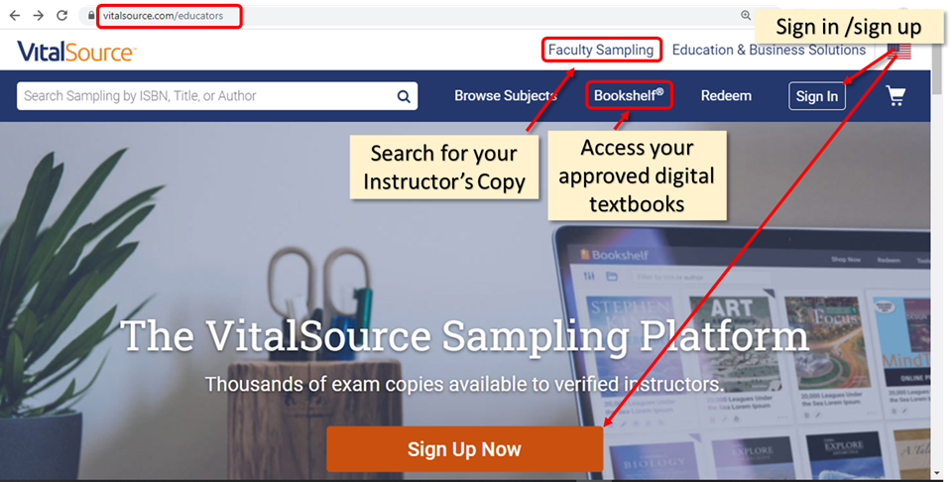
Figure 7.1. Homepage of VitalSource with main parts highlighted
- A verification email and approval process is straightforward and takes no time. Once books are added, the educator can access his/her bookshelf and start browsing them, listen to them using the built-in reader (Read Aloud), highlight text, copy them, add bookmarks, and create sets of flashcards that can be presented on screen or share them as study guide with students.
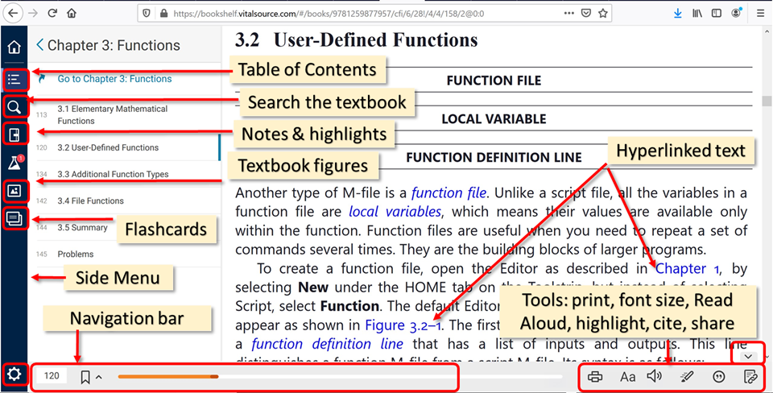
Figure 7.2. VitalSource Textbook browsing screen with main components highlighted.

- OERCommons.org
- OER Commons is an OER repository, which indexes many other OER providers such as …. It is a good idea to start looking for teaching components at different OER to utilize or remix before preparing new course materials.
- MARLOT.org
- Multimedia Education Resource for Learning and Online Teaching (MERLOT) developed by California State University.
- cccOER.org
- Community College Consortium for OER

- Other OER include:
  - MIT,
  - Opencourselibrary.org by Washington State University
Make the presentation life and interactive, use smart board, tablet with built-in pen. Add some short animated video using one of the animation platforms such as Powtoons.com, animiz.com, biteable.com , animaker.com or Vyond.com Most of these animation tools are web-based and require subscription for full access but they offer free limited accounts which are good to add some short animations here and there to give more attraction and extra flavor to the class contents.

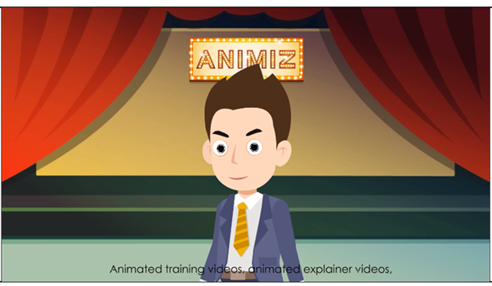
Animiz animation tool can be used to produce short animated contents
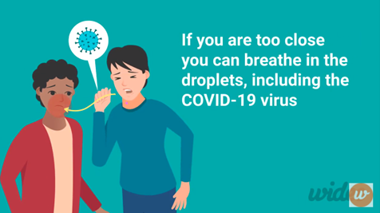
Wideo, another tool to create short animated contents

Smart boards are available in some buildings such as CSTB. https://www.smarttech.com/products/education-displays/smart-board-6000
Sympodiums are also available at many classrooms throughout the campus.
They both come with a smart notes/white board app that allows the use of many tools in lecturing, customize notes, saving annotated notes, and adding web contents to them.

References

Herold, B. (2016, February 5). Technology in Education: An Overview. Education Week. Retrieved June 20, 2020 from http://www.edweek.org/ew/issues/technology-in-education/

How Has Technology Changed Education? (n.d.) Purdue Online. Retrieved June 20, 2020 from https://online.purdue.edu/blog/education/how-has-technology-changed-education

Jon Marcus (2020, February 20). How Technology Is Changing the Future of Higher Education. Retrieved June 20, 2020 from https://www.nytimes.com/2020/02/20/education/learning/education-technology.html

The Evolution of Technology in the Classroom. (n.d.) Purdue Online. Retrieved June 20, 2020 from https://online.purdue.edu/blog/education/evolution-technology-classroom

Zack Friedman (2019, May 29). Here Are The Top 7 Websites For Free Online Education. Retrieved June 20, 2020 from https://www.forbes.com/sites/zackfriedman/2019/05/29/free-online-education/

CHAPTER 8: RISK ASSESSMENT IN EXPERIENTIAL LEARNING
As professors, we strive to present the best learning environment possible, and it is expected that universities will act with reasonable care to prevent foreseeable harm to students (Bickel & Lake, 1999). When we include experiential learning components in our classes, identifying and effectively dealing with risks is imperative for the safety of students, faculty and community members and to reduce the University’s liability.
Risk managers recommend these four steps when developing an experiential learning component in a class: identify potential risks, assess the likelihood of risk, manage the risk(s), and then monitor the risk(s).
The common risk areas involved with undergraduate experiential learning fall under the categories of transportation, location, project activities, special populations, and community partners. In general, the most effective risk mitigation strategy is to inform, orient and train students before their real world experience.
What Could Go Wrong? Identify Potential Risks
The first step is to consider potential hazards that may be involved with a particular activity. These should be hazards or risks involved in all aspects of an experiential learning course component but should also be those reasonably foreseen. For example, a student service-learning project that is done electronically from the classroom does not have any identified potential risks to the students. However, participating in a project on an off-campus location would include the risks involved with driving to and from the location, parking issues, and any potential hazards involved with the physical site.
How Likely is Something to go Wrong?
The next step is to assess the risk(s). How likely is a hazard occurrence? Using a qualitative likelihood scale with categories ranging from a rare occurrence to near certain to occur may be instructive (University of Tennessee Knoxville 2018). In the example above, a potential risk may be involved with driving to the off-campus location. A reasonable assessment is that students driving their own vehicle get lost en route.
What are the Consequences if it does Occur?
The next questions are about the ramifications. Obviously, the most serious consequences are to a student’s well-being: physical or otherwise. The impact of something going wrong ranges from Insignificant to Catastrophic. The student above gets lost driving in an unfamiliar area. Some of the consequences may be the student experiences anxiety and was late for the activity.
How Can the Likelihood of Risk be Eliminated or Reduced?
To manage risk there are various options. One is to treat risk. The most common way is through information- holding safety orientations, training sessions, discussions with community partners, in essence lots of participant education. Another way is to transfer risk, that is, shift the responsibility of risk, especially financial, to a third party, most often by purchasing or requiring insurance, or to require the students to sign liability waivers. Some Real World Ready courses include “Hold Harmless” documentation for participants as well (see below). Another option is to terminate the activity particularly if the potential for harm is too severe. After risk has been reasonably managed through treatment, transfer, and high-risk activities terminated, the remaining risk should be tolerated. In the example above, the faculty member could treat potential risks by providing information, both in written and oral forms, about the drive, specific directions, and maps. The required Off-Campus Individual/Group Visitation Forms that would include the students’ contact information would also manage risk. The instructor could also consider sharing their contact information, including cell phone numbers, with students to use in case of emergency. Another factor in the example would be weather conditions on the day of the activity. If conditions were such that driving could be hazardous, the activity would be cancelled (termination).
Much of risk management is common sense and giving some careful thought to the risk management process beforehand is necessary. Developing and teaching a class with an experiential-learning component involves additional responsibility but given that care will result in meaningful learning outcomes.
Suggested Risk Management Protocols
Risk management for community engagement or service-learning projects, especially those that occur off campus, should include set protocols. Some of the standard outside affiliation agreements (see Appendix A) also pertain to risk management and liability.
Affiliation Agreement/Memorandum of Understanding
When working with a community partner or organization, faculty must first complete an Affiliation Agreement/Memorandum of Understanding (MOU). This agreement articulates the objectives and purposes of the experiential learning course component and the details of the project or activity. The agreement must be signed, following the correct routing beginning with the professor, executed before the experiential course component begins.
This agreement must include a mutual indemnification clause with the specific language below and must be signed by the professor, the department head, dean, and the outside organization:
A. Southeastern Louisiana University, shall indemnify, defend and hold harmless AGENCY NAME from any or all claims, demands, and expenses of any kind, including attorney’s fees, which result from or arise out of any act or omission of its students or faculty members relating to the terms and conditions of this Agreement.
B. AGENCY NAME shall indemnify, defend and hold harmless Southeastern Louisiana University from any or all claims, demands and expenses of any kind, including attorney’s fees, which result from or arise out of any act or omission of its agents and employees relating to the terms and conditions of this Agreement.
An important note: if the Provost and President have already signed Affiliation Agreements for students to do the work specified in experiential-based courses at the sites and during the periods indicated in those signed Affiliation Agreements, then those Affiliation Agreements/MOUs are sufficient. In these instances, a second Affiliation Agreement/MOU from the professors is not required. Professors should keep executed Affiliation Agreements/MOUs with outside partners on file. All signatures should be secured before a student begins the experiential-learning opportunity.
Agreement of Student Responsibilities
At the beginning of each semester, students and professors should sign an Agreement of Student Responsibilities in experiential-learning courses. This ensures the student understands that the course includes an experiential-learning component and understands the requirements involved with such activities. Any potential risks involved with the experiential learning component should be explained as well. The faculty member should keep the originals on file.
Off-Campus Visitations
The Office of the Dean of Students manages requests for student off-campus travel. Prior to travel the faculty member must submit the visitation form that includes the reason for travel, location, mode of travel, proof of driver's license and automobile insurance, and contact information. The form states that students will be responsible for adhering to all state and local laws, the Southeastern Code of Conduct, the Southeastern Drug and Alcohol Policy, and other University rules and regulations (https://www.southeastern.edu/admin/stu_affairs/policies_procedures/assets/Off_Campus_Individual_Group_Visitations_18.pdf).
Each student must also sign the Off-Campus Individual/Group Visitations Expected Behaviors form: (https://www.southeastern.edu/admin/stu_affairs/policies_procedures/assets/off_campus_behaviors_new.pdf). A copy of the signed form should be given to the student and the original kept on file by the faculty member.
The Office of the Dean of Students recommends that faculty supervising students doing off-campus activities have students fill out an information form with student cell phone numbers, emergency contacts, and any medical issue information. The form is available here:
(https://www.southeastern.edu/admin/stu_affairs/policies_procedures/assets/Fac_Staff_Off_Campus_Checklist_updated_May_2015.pdf)
Having an emergency management protocol in place is recommended for the safety of students, faculty and experiential learning community partners. The protocol should include steps a faculty member and the community partner designee take when a student is injured or harmed in any way while participating in an experiential learning activity.
Southeastern Resources
These campus offices may have information about specific risk assessment and Management issues:
Division of Student Affairs, Office of the Dean of Students (deanofstudents@southeastern.edu) especially for off-campus visitation information http://www.southeastern.edu/admin/stu_affairs/

University Health Center http://www.southeastern.edu/admin/health_ctr/index.html

University Counseling Center http://www.southeastern.edu/admin/counseling/index.html

Office of Disability Services http://www.southeastern.edu/admin/ds/index.html

Office of International Initiatives http://www.southeastern.edu/acad_research/programs/ii/index.html

University EEO and ADA Compliance Officer Gene Pregeant (gpregeant@selu.edu)

Office of Environmental Health and Safety http://www.southeastern.edu/admin/safety/index.html

Southeastern Louisiana University Police Department http://www.southeastern.edu/admin/police/index.html

Southeastern’s Emergency Response Guide:
https://www.southeastern.edu/resources/policies/policy_detail/emergency_procedures.html

Other Sources of Risk Assessment and Risk Management Information:

State of Louisiana Office of Risk Management. https://www.doa.la.gov/Pages/orm/Index.aspx

Center for Community Engagement, Learning and Leadership, Louisiana State University
https://www.lsu.edu/academicaffairs/ccell/faculty_resources/ccell_policies_and_forms.php

References

Bickel, R. D., & Lake, P. F. (1999). The rights and responsibilities of the modern
university. Carolina Academic Press.

University of Tennessee Knoxville. Teaching and Learning Innovation. Risk
Management Handbook.
https://experiencelearning.utk.edu/wp-content/uploads/sites/21/2018/09/442930-
EL-Risk-Management-Update-v1.0accessible.pdf

CHAPTER 9: ASSESSMENT

The concept of assessment is ongoing, evolving, and in constant motion. Initially assessment in the experiential-learning environment is laying the groundwork identifying how the community at large may be best used for the student to achieve course objectives in a real-world ready environment. Assessment may be defined as
“…a means to develop and refine the specific learning goals and quality objectives identified during the planning stages of the experience while evaluation provides comprehensive data about the experiential process as a whole and whether it has met the intentions which suggested it” (Beck, Boys, Haas & King, 2017, p. 111).
Assessment gathers data for verification of learning outcomes whereas evaluation uses the data for program change to make the outcomes more consistent (Brumbaugh, Dressler, Drysdale, & Walters, 2018).
Assessment may occur throughout the experience, at a defined time, or at the end of the experience. Formative assessment occurs at a defined time or regularly over time whereas summative assessment occurs at the end of the experience (Maki, 2010). Assessment that takes place throughout the experience or activity ensures learning and the effectiveness of teaching strategies. Examples include tests, quizzes, papers, projects, discussion board, and group work (Maki, 2010). Formative assessment is often termed assessment for learning. Students are provided feedback throughout the experience and can tailor their learning to meet the course objectives. Assessment also takes place at the end of a course, experience, activity, or at the end of a program. Summative assessment is termed assessment of learning, which measures how the student completed a specific task or assignment. Assessment of learning involves the students relating their prior learned knowledge to the new experience, which guides in their development of metacognitive skills (LINCS, n.d.). Student evaluation of teacher, student evaluation of mentor or preceptor, student evaluation of facility, course evaluations, exit / end of program surveys and alumni surveys are all examples of assessment that take place at the end of a course or program.
Principles of assessment of experiential learning are developed from the National Society for Experiential Education’s (NSEE) Eight Principles of Good Practice for All Experiential Learning Activities. These principles include intention, preparedness and planning, authenticity, reflection, orientation and training, monitoring and continuous improvement, assessment and evaluation, and acknowledgement (National Society for Experiential Education, 2013). The initial intentions of the experiential experience along with the expected quality outcomes are developed prior to the experience. Ongoing throughout the experience the outcomes are assessed regarding how they are matched with the initial intentions.
Students acquire a variety of problem-solving skills and knowledge sets during their experiential learning activity or experience. This poses a challenge for the educator when evaluating the students’ performance, as students will learn different skill sets within the same course or experiential-learning activity. Their experiences will differ allowing each student to develop their problem-solving skills related to their experience (Teaching and Learning Services, 2014). The educator needs to develop the assessments based on the learning outcomes, which measure student performance during and after the experience.
To assess the students’ garnered knowledge and to identify strengths and weaknesses of the curriculum, a variety of assessment methods should be employed (Maki, 2010; Peng & Fu, 2017). Assessment methods may be direct, indirect, qualitative, and or quantitative (Maki, 2010). Direct assessment is the educator’s or the persons performing the assessment perception of student learning (Peng & Fu, 2017). The student’s product is assessed in direct correlation to the expected outcomes (Northeastern University, 2019). Using direct assessment, student learning is measured with course assignments such as papers, student projects, team-based projects, journals or portfolios. Other examples of direct assessment measures include performance assignments pertaining to internships, externships, or service-learning projects; observation of performance, traditional tests, presentations, discussion board assignments, and or visual performance (Peng & Fu, 2017). Indirect assessments provide an opportunity for all parties to reflect on the work students are producing and report to the educator with their opinion and perception of the students’ learning experience (Palomba & Banta, 1999). Although indirect methods are helpful when interpreting the findings of direct assessments, they are not as useful in identifying specific knowledge and skill strengths and deficiencies. Indirect assessment is reviewing the student’s perception of learning by obtaining information through surveys, questionnaires, inventories, student evaluations, self-evaluations, exit interviews and focus groups (Peng & Fu, 2017). Assessment methods may also include collecting both qualitative and quantitative data.
Assessment of an experiential-learning activity begins with the development of learning outcomes (Teaching and Learning Services, 2014). When developing learning outcomes, answering essential questions posed by Qualters (2010) will guide the process. Qualters’ questions ask, “Why are we doing the assessment?”, “What are we assessing?”, “How do we want to assess in the broadest terms, and “How will the results be used?” (p.56). After identifying these answers, the next step is to answer questions specific to the experiential-learning experience or activity: “These are questions that all parties involved in the experiential experience are really concerned about answering” (Qualters, 2010, p. 57). What are the vested parties concerned about the experiential experience or activity? The learning outcomes and assessment methods are derived from these answers.
Deciding on the assessment tool is the next step in the assessment process. As previously identified, there are various tools used to assess student learning. Deciding on which tool that best fits the experience may be daunting. The assessment tool should be student-centered (Schwartz, 2012).
Reflective journals may be useful for students who are visiting a specific work site or location recording observations over a specific period (Teaching and Learning Services, 2014). Providing a framework for the student to follow will be most effective. Questions posed by the educator will guide the student’s journal entry. Asking the student how the experience improved the student’s knowledge and how the new knowledge relate to the course content are example questions used in reflective journaling.
The role of reflection is one of the most frequently discussed topics in experiential learning, especially in skills based classes. For many instructors, reflection assignments can be frustrating and leave them questioning whether their students are actually getting anything from it.
For students and teachers, reflection can be as uncomfortable and awkward as an ill-fitting jacket. Achieving that “perfect fit” requires some tailoring or tweaking. Believe me, I know reflection isn’t easy. One professor notes: I teach a skills-based research class, LS102. About a year ago, two colleagues and I revised various assignments to increase experiential learning in our classes. Our biggest challenge was creating useful and meaningful reflections.
Lifelong Learning
Reflection as a tool for learning, particularly lifelong and integrated learning, was a topic of many presentations I attended this year. While I had always viewed reflection as important for making immediate connections, I had not thought of it as a tool for these types of learning.
Yet, it makes sense in relation to Bloom’s Taxonomy, which describes different degrees to which learners demonstrate knowledge. Students often must move through the lower level activities (e.g. remembering, understanding) before they can successfully participate in higher-level activities (e.g. analyzing, evaluating).
In a recent campus presentation, Lily Brooks distinguished between reflection as a vehicle for both lower order thinking skills and higher level thinking skills. In lower order reflections, students might recount events and supply only general statements or vague descriptions. In other words, students focus only on “what I did today.”
This level of reflection can be helpful in building knowledge. For example, when students are learning about keyword searching in my class, I ask them to create search phrases based on tools they learned from pre-class readings. Based on in class discussion, it is often easy for them to mimic the proper format without understanding why we are using those tools. To further their understanding, I use this reflective question: List each tool used above and briefly explain why you used them.
Asking them to reflect on their choices allows them to move from the general knowledge of what the tools look like to a more specific understanding of how they work and when they should be used.
In higher-level reflections, students connect their experiences to course material, offer more evaluative statements, specific examples and analysis, and/or discuss applications to the future. In other words, students begin thinking beyond “what I did” to “what I will do.” From this level of reflection, students build and deepen connections that allow them to transfer knowledge between situations as well as critical thinking and problem solving skills.
For example, when my students are learning about field searching, I have them experience moving from a keyword search to a combination keyword and subject search. After they have completed that activity, I ask them this reflective question:
In a comprehensive paragraph, reflect on what you have observed. Make sure that your paragraph answers all of the following questions with supporting detail and explanation: Based on this knowledge, could you further narrow your results? How—and why might you decide to do so?
In this reflection, students describe what they have done, along with how they might react or respond in future research situations. This reflection allows students to supply real life examples from their experiences with research or tools used in our previous classes, thus further building connections to what we are learning.
Types of Reflection
Professor Jack Bedell has described three particular types of reflection and their potential uses, as well as included some sample questions. Which type(s) of reflection you use, and in what combination, will depend on what you hope to accomplish in your class.
- Cognitive Reflection
Cognitive reflection is based on knowledge, whether from the course or prior experience. Bedell indicates that this type of reflection helps students make the abstract more concrete as they build connections between their book knowledge and their prior knowledge. This type of reflection also directly addresses the curriculum.
Sample Questions:
Were the goals and objectives of the EL activity accomplished? Describe how relates to X.
How has your EL related to course readings, discussions, and lectures in your courses? Provide specific examples.
Did your understanding of course materials/course improve because of EL? Provide examples.
- Affective Reflection
Affective reflection is based on feelings towards an experience. Bedell indicates that this type of reflection looks at how students’ attitudes and opinions have changed because of their learning. It can be motivational, as seeing positive changes encourages students to continue, but even negative experiences can help them develop greater insight and to see their own growth.
Sample Questions:
Would you do this again? Why?
Has this experience changed you? If yes, how?
What values/beliefs/opinions have changed for you?
- Process Reflection
Process reflection is an analysis of the experience and its stages. Unlike the cognitive reflection, which fleshes out the abstract, process reflection helps students assemble a bigger picture than their individual experiences. Bedell gave as examples that students may write about how the experience helped them work better in teams or in understanding the consequences of particular actions.
Sample Questions:
What expectations did you have before, and were they met?
What would you change about your experience?
What were the benefits from participating in this activity?
Student presentations is another example of an assessment tool. The presentation may be individual or group work and can use both peer and self-assessment (Schartz, 2012). Presentations may be performed at an academic or professional conference or may be held during assigned class time. Consider inviting the community members who are involved in the experiential learning experience.
A portfolio documents student progress over time (Teaching and Learning Services, 2014). Qualters notes: “The learning portfolio is one of the most comprehensive methods of assessing experiential learning” (Qualters, 2010, p. 60). Learning portfolios differ from standard professional portfolios as the addition of a reflection element (Qualters, 2010). In addition to assessing student learning, portfolios may be used in an accreditation process.
When using a portfolio as an assessment tool, the educator first should determine the purpose of the portfolio, have an awareness to what type of reflective questions the students would need to answer, know what evidence of learning outcomes would be relevant, and recognize how the students will collaborate during the experience (Zubizarreta, 2008; Schwartz, n.d.). The educator should know there is no correct way of developing a portfolio and the students’ portfolios will differ depending on the experiential learning activity (Schwartz, n.d.). Suggestions as to the possible contents of a portfolio and a sequential order outlined by Zubizareta (2008) includes
1. Philosophy of learning: What, how, when, and why did I learn? A reflective narrative on the learning, process, learning style, value of learning.
2. Achievements in Learning: What have I accomplished with my learning? Records—transcripts, course descriptions, resumes, honors, awards, internships, tutoring.
3. Evidence of Learning: What products, outcomes do I have to demonstrate learning? Outcomes—research papers, critical essays, field experience logs, creative displays/performances, data/spreadsheet analysis, lab results.
4. Assessment of Learning: What measures and accounting do I have of my learning? Instructor feedback, course test scores, exit/board exams, lab/data reviews, research project appraisals, practicum reports.
5. Relevance of Learning: What difference has learning made in my life? Practical applications, leadership, relation of learning to personal and professional domains, ethical/moral growth, affiliations, hobbies, volunteer work, affective value of learning.
6. Learning Goals: What plans do I have to continue learning? Response to feedback; plans to enhance, connect, and apply learning, career ambitions (p. 4).
Using a learning portfolio as an assessment tool enables the student to document and reflect on their personal journey of their personal experiential learning experience. This engagement in the assessment process facilitates them to become more independent and self-directed students (Zubizarreta, 2008).
A well-constructed rubric is a very powerful assessment tool (Rubrics for Experiential Learning, 2017). The educator may identify gaps or strengths in student learning when tracking rubrics over time. When rubrics are implemented successfully, they have been shown to “…provide timely feedback, prepare students to use detailed feedback, encourage critical thinking, refine teaching methods, and facilitate communication with others” (Stevens & Levi, 2013, p. 28). The well-developed rubric includes specific criteria used to assess students’ performance (Brookhart, 2013). An effective rubric creates an organized way to assess students’ knowledge and facilitates expedient feedback to the students (Steven & Levi, 2013). Southeastern Louisiana University has developed and implemented the use of analytic rubrics geared to assess student learning. The SLU’s Holistic Master Rubric assesses the students’ behavior, their work, and their experience on a scale from 1 to 3 (Southeastern Louisiana University, 2017; Appendix D).
Assessment is a vital tool used to ensure student learning is effective, instructional and or to ensure the efficacy of a course. This includes a systematic gathering of data to make an informed decision regarding learning outcomes. There are several tools, strategies, and methods available to complete an assessment. The purpose to conduct an assessment is to ensure student learning has taken place, improve student learning in the future, to demonstrate the value of a program, and to advocate and promote a program. Other important reasons are to satisfy accreditation requirements, and to adhere to good practice.
Critical outcomes of the assessment process include student learning, student satisfaction, effective classroom instruction, civic activism, professionalism, ethical behavior, and program outcomes and goals. Everyone involved in the teaching-learning process should be involved in the assessment. This includes course faculty, program directors, students, and curriculum experts within the department, school, and community of interest (others internally and externally).
Best practice for assessment development includes an assessment plan that evaluates student learning outcomes systematically, intentionally, and frequently throughout the course. It is also critical to incorporate multiple assessment techniques throughout the course due to the vast diversity in teaching-learning preferences.

References
Beck, V., Boys, S., Haas, H., & King, K. (2017). How do you use experiential learning to bridge the classroom and the real world? In R. Gurung & D. Voelher (Eds.), Big picture pedagogy: Finding interdisciplinary solutions to common learning problems: New directions for teaching and learning (1st ed., pp. 96-116). Jossey-Bass. DOI: 10.102/tl
Bedell, J. and Brooks, L. (2017) Effective Prompts for Reflective Writing. Presentation at Lunch-N-Learn for Southeastern Louisiana University. Hammond, LA.
Brookhart, S.M. (2013). How to create and use rubrics for formative assessment and grading. ASCD.
Brumbaugh, P., Dressler, S., Drysdale, M., & Walters, J. (2018, September 20-26). Assessment workshop [Conference session]. National Society for Experiential Education Annual Conference, Savannah, GA, United States.
Grouse, A. (2016) Internship pathways for integrative learning. Presentation at the 45th National Society for Experiential Education Conference. San Antonio, TX
LINCS (n.d.). TEAL center fact sheet No. 4: Metacognitive processes. Retrieved from https://lincs.ed.gov/state-resources/federal-initiatives/teal/guide/metacognitive
Loebick, K., Blalock, E., and Rivera, J.E. (2016) Integrations made visible with the use of ePortfolios. Presentation at the 45th National Society for Experiential Education Conference. San Antonio, TX
Maki, P. (2010). Assessing for learning: Building a sustainable commitment across the institution (2^{nd.} ed.). Sterling, VA: Stylus.
National Society for Experiential Education. (updated 2013, December 09). Eight principles of good practice for all experiential learning activities. [Presentation] 1998 Annual Meeting, Norfolk, VA. Retrieved from https://www.nsee.org/8-principles
Northeastern University (2019). Assessment methods. https://learning.northeastern.edu/app/uploads/2019/02/Direct-and-Indirect-Assessment-Methods.pdf
Palomba, C. & Banta, T. (1999). Assessment essentials: Planning, implementing, and improving assessment in higher education. Jossey-Bass.
Peng, R., & Fu, R. (2017). Darla Deardorff: Demystifying outcomes assessment for international educators: A practical approach. High Educ 74, 197–199. https://doi.org/10.1007/s10734-017-0135-z
Qualters, D. M. (2010). Bringing the outside in: Assessing experiential education. New Directions for Teaching and Learning, 2010(124), 55-62. https://doi.org/10.1002/tl.421
Rubrics for experiential learning. (2017). The University of Tennessee Knoxville, Teaching & Learning Innovation. Retrieved May 1, 2020 from https://experiencelearning.utk.edu/wp-content/uploads/sites/21/2017/08/Rubrics-for-Experiential-Learning.pdf
Schartz, M. (2012). Best practices in experiential learning. Ryerson University Learning and Teaching Office. Retrieved from https://www.ryerson.ca/content/dam/experiential/PDFs/bestpractices-experiential-learning.pdf
Schartz, M. (n.d). Best practices in experiential learning. Ryerson University Learning and Teaching Office. Retrieved from https://www.mcgill.ca/eln/files/eln/doc_ryerson_bestpracticesryerson.pdf
Southeastern Louisiana University (2017). Real-World ready faculty grants criteria and application. https://www.southeastern.edu/acad_research/programs/el/assets/RWRGrantApplication2017-2018.pdf
Stevens, D.D., & Levi, A.J. (2013). Introduction to rubrics (2nd ed.). Sterling, VA: Stylus.
Teaching and Learning Services. (2014). Guidelines for assessment of experiential learning. Montreal: Teaching and Learning Services, McGill University. Retrieved January 14, 2020 from https://www.uottawa.ca/shape-your-experience/sites/www.uottawa.ca.shape-your-experience/files/ressources_professorales_-_evaluer_ae_-_mcgill.pdf
Zubizarreta, J. (2008). The learning portfolio: A powerful idea for significant learning. Manhattan, KS: Idea Center, Idea Paper No. 44. Retrieved June 1, 2020 from https://www.ideaedu.org/Portals/0/Uploads/Documents/IDEA%20Papers/IDEA%20Papers/IDEA_Paper_44.pdf

CONCLUSIONS
Experiential learning provides opportunities for students to practice in a setting that is authentic to advancing their intended careers. These learning opportunities are current, pertinent, performance-based, practical applications of knowledge and skills experienced within the curriculum. Academic research indicates “learning by doing” in combination with coursework can improve student success.
At Southeastern, experiential learning falls into categories that will vary by discipline and academic major including, but not limited to, internships, service-learning, undergraduate research, civic engagements, study abroad/away, field experiences, creative activities, practice, hands-on learning, mentoring, leadership training, student teaching, and apprenticeships. Professors should choose the types of experiences that will best prepare students for their future careers and, then, to adopt best practices to ensure successful delivery.
There are two primary missions for offering experiential-learning opportunities to Southeastern students:
- To bring EL into better partnership with the bedrock of academic rigor (reading, thinking, writing, and reflection) in an effort to serve students more effectively
- To support and engage students, faculty, and community partners in meeting the challenges of preparing students for twenty-first century workforce demands.

The campus Real-World Ready initiative (2015-20) helped to create a campus climate for embracing experiential education across the disciplines. All programs are encouraged to continue developing their EL programs to ensure the extension of RWR for many years to come.

Select Bibliography
Armstrong, P. (n.d.). Bloom's taxonomy. Vanderbilt University. https://cft.vanderbilt.edu/guides-sub-pages/blooms-taxonomy/ CC BY-NC

Association for Experiential Education. (n.d.). https://www.aee.org/

Association of American Colleges & Universities. (n.d.). VALUE rubric development project. AACU. https://www.aacu.org/value/rubrics

Auon, J. E. (2015). A complete education. Inside Higher Ed. https://www.insidehighered.com/views/2015/04/20/essay-calls-ending-divide-between-liberal-arts-and-practical-education

Brandeis University. (n.d.). Experiential learning and teaching. https://www.brandeis.edu/experientiallearning/

Campus Compact. (n.d.). https://compact.org/

Corporation for National and Community Service. (n.d.). https://www.nationalservice.gov/

Corporation for National and Community Service. (n.d.). United we serve. https://www.nationalservice.gov/blogs/united-we-serve

Council for the Advancement of Standards in Higher Education. (n.d.). https://www.cas.edu/

Council for the Advancement of Standards in Higher Education. (2018). Civic engagement and service-learning programs. http://standards.cas.edu/getpdf.cfm?PDF=E86EC8E7-9B94-5F5C-9AD22B4FEF375B64

Council for the Advancement of Standards in Higher Education. (2018). Internship programs. http://standards.cas.edu/getpdf.cfm?PDF=E86CFB4D-0B9E-4853-6D82720BE0779895

Council for Adult and Experiential Learning. (n.d.). https://www.cael.org/

Elmhurst College. (n.d.). Experiential learning. https://www.elmhurst.edu/academics/undergraduate/integrated-curriculum/experiential-learning/

Howard, J. (2001). Principles of good practice for service-learning pedagogy. NSEE, https://nsee.memberclicks.net/assets/docs/KnowledgeCenter/EnsuringQuality/AcademicJournals/170. principles of good practice for service learning 16-19.pdf
Journal of Community Engagement and Scholarship. (n.d.). http://jces.ua.edu/

Jay W. Roberts. (n.d.). https://jaywroberts.com/

Journal of Experiential Education. (n.d.). Sage Journals. https://journals.sagepub.com/home/jee

Journal for Experiential Learning. n.d. Touro College. https://digitalcommons.tourolaw.edu/jel/

Journal of Higher Education Outreach and Engagement. (n.d.). University of Georgia. https://openjournals.libs.uga.edu/index.php/jheoe

Learn and serve America. (n.d.). Community-Wealth. https://community-wealth.org/strategies/policy-guide/lsa.html

Maryville College. (n.d.). Experiential learning. https://www.maryvillecollege.edu/academics/learn-by-experience/

Meyer, D. (1992). John Dewey: Philosophy and education. The University of Chicago Faculty: A Centennial View. https://www.lib.uchicago.edu/projects/centcat/fac/facch08_01.html

Moon, J. (2001). Reflection in higher education learning. Brandeis University. https://www.brandeis.edu/experientiallearning/currentpdfs/reflectioninhighered.pdf

National service-learning clearinghouse. (n.d.). Community-Wealth. https://community-wealth.org/content/national-service-learning-clearinghouse

National Society for Experiential Education. (n.d.). https://www.nsee.org/

New Directions for Adult and Continuing Education. (n.d.). Wiley Online Library. https://oibrary.wiley.com/journal/15360717nlinel

Regis University. (n.d.). Active learning: An integrated team-based approach. https://www.regis.edu/RHCHP/Schools/School-of-Pharmacy/Active-Learning.aspx

Roberts, J. (2008). From experience to neo-experiential education: Variations on a theme. Journal of Experiential Education, 31(1), 19-35. https://doi.org/10.1177/105382590803100104

Roberts, J. W. (2016). Experiential education in the college context [Presentation slides]. Mindomo. https://www.mindomo.com/mindmap/experiential-education-southeastern-louisiana-14de58641499c1ef9fbc2537320a5216

Southeastern Louisiana University. (2019). Experiential learning resources. LibGuides. http://selu.libguides.com/experientiallearning

University of Texas at Austin. (n.d.). Experiential learning. https://facultyinnovate.utexas.edu/experiential-learning

University of Washington. (n.d.). Undergraduate programs experiential learning. https://education.uw.edu/programs/undergraduate/experiential-learning

Volunteer Louisiana. (n.d.). https://volunteerlouisiana.gov/

Internship Infographics: https://elearninginfographics.com/?s=interns

APPENDICES
Appendix A: Example of Affiliation Agreement

host company Affliliation Agreement for internship
department of history & political science
CRMP 491/492 – A REal world ready course

The purpose of this agreement is to establish the framework for an internship and to describe reasonable expectations regarding the work to be performed by the intern. Since the internship will result in a course grade and credit for the student, we ask that reasonable access be granted to the student and the student’s immediate supervisors at your company or institution for the purposes of course evaluation and assessment. Please note that this document is not a legally binding document, except for Section 9 below (the “hold harmless” agreement), and is designed primarily as a means of outlining expectations on the part of the student/intern, Southeastern Louisiana University (“university”), the History and Political Science (“HIPS”) Department, and the Host Company for the internship.

The following is a list of requirements and details that you should be aware of and to which you must agree fir the internship to be approved by the HIPS Department:

1. A student taking on an internship to qualify for credit must register for the CRMP 491 or CRMP 492 RWR course and have that registration approved by the instructor of record (Dr. Samantha Cavell) and the Department Head (Dr. William Robison). For this approval to take place the following information is required:
a) Contact information for the designated company or institutional supervisor who will oversee the student during the internship.
b) A summary of the responsibilities and tasks that the student will need to accomplish.
c) A list of projected outcomes for the intern in terms of what they are expected to learn and/or experience and how these outcomes might improve the intern’s prospects for employment in their intended career.
d) A signed copy of this agreement.

2. It is the Host Company’s responsibility to establish the student’s identity and employment eligibility as may be required. Student interns are instructed to provide any documents that may be required to establish eligibility. It is also the Host Company’s responsibility to establish the student’s skills and ability to perform the required internship tasks.

3. By the first day of the internships, the Host Company’s intern supervisor or other designated company officials must provide the student with the pertinent company policies regarding conduct, safety rules and procedures, intellectual property policies, use of technology, e-mail use policies, and any other company rules and regulations that pertain to the work environment of the Host Company.

4. Employment that may be part of an internship program is expected to last no longer than the period of the internship CRMP 491 and 492 course (see dates below). Any extension of employment beyond the time frame of the course for which the student is registered is strictly between the company and the student. The university is not required to provide any further course credits, nor is the university part of any further company-student agreements or employments.

5. It is understood that both the student and Host Company agree to employment on an “at will” basis. The student engages in this internship as an “at will” intern, free to resign at any time, for any reason,
with or without cause or notice. Similarly, the Host Company is free to terminate the internship at any time, for any reason, with or without cause or notice. The “at will” status of the internship cannot be modified expect by written agreement signed by both the student and a representative of the Host Company, and the university is no way part of this agreement. In the case of either resignation or termination, however, both the student and the Host Company must notify the university and the internship coordinator since a grade may still need to be assessed.

6. Either the Host Company or the university may require the withdrawal or dismissal of any student if his/her performance record or conduct does not justify continuance.

7. While engaged in the internship, the student retains the status of a student working towards the fulfilment of an elective course for a degree requirement. The student is not an employee of the university as a result of performing the internship. The purpose of the internship is for the student to learn skills and practices that enhance his/her education in a “real world” environment pertinent to his/her intended career. There is no guarantee or expectation that the internship activity will result in further employment with the company beyond the internship period.

8. The Host Company agrees to provide the student with learning opportunities through assignments that allow them to learn as well as contribute, and to submit the Performance Evaluation detailing the intern’s development and achievement.

9. Hold harmless:
a) Southeastern Louisiana University shall indemnify, defend, and hold harmless the Host Company from any and all claims, demands, and expenses of any kind, including attorney’s fees, which may result from or arise out of any act or omission of its students or faculty members relating to the terms and conditions or this agreement.

b) The Host Company shall indemnify, defend, and hold harmless Southeastern Louisiana University from any and all claims, demands, and expenses of any kind, including attorney’s fees, which may result from or arise out of any act or omission of its agents and employees relating to the terms and conditions of this agreement.

Southeastern Louisiana University Host Company:

By: ___________________________________ By: __________________________________
Karen Fontenot Date: _____________ Name: __________________ Date:_________
Dean, College of AHSS Title: __________________________________

By: ____________________________________
William Robison Date: _____________
Dept. Head, Dept. of History and Political Science

By: _____________________________________
Samantha Cavell Date: _______________
RWR CRMP 491/492 Coordinator, Dept. History and Political Science

By: _____________________________________
Student Name: ____________________________
W#: _________________________
Date: ________________________

Appendix B: Example of a Service-Learning Syllabus

A Real World Example of Civic Engagement

Students in Anthropology 410 (Culture and the Environment) worked for an international non-governmental organization (NGO) as part of this Real World Ready course. I developed this course with an experiential learning component in mind upon my return to teaching after a year in East Africa. This was a perfect opportunity to introduce students my academic and research interests in human-wildlife dimensions and engage them with community work.

Over months of electronic communications with colleagues in Tanzania affiliated with an international NGO, we came up with potential student projects. These projects were directly related to the academic focus of the class but were also products or work that the organization needed. We met with the staff in Tanzania via Skype during class time.

Course Syllabus

ANTH 410

Culture and the Environment

Course Description: A study of the diverse and complex interactions between human
culture and the environment.

Overview: This course aims to provide undergraduate students of anthropology the opportunity to explore the possibilities of their work beyond the confines of a traditional academic class. Through this course, students will experience ways in which anthropology – its theories, methods, and overall orientation as a field – can take transformative action, and how anthropology offers students many undiscovered possibilities for study, employment, and self-enrichment.

This is a Real World Ready class that incorporates an experiential-learning component to supplement classroom instruction.

This semester, students will concentrate on the work of a nongovernmental organization, learning about human-wildlife conflict, conservation, and social problems addressed. Students will work on projects in a professional manner (e.g. meeting deadlines, submitting high quality professional documents and other products) while making connections with academic learning.

Course Objectives: During this course students will: 1) become familiar with the concepts, methods and theories of anthropology; 2) gain an understanding of cultural ecology; 3) gain an understanding of conservation and the human dimensions; 4) understand the issues related to local land use and wildlife behavior; 5) gain an in depth understanding of the mission, operations and projects an international nongovernmental organization concerned with conservation and development in Tanzania; 6) apply anthropological concepts and methods while working with the organization (internet based); 7) make meaningful connections between academic and experiential learning; and 8) present project results in a professional venue.

Real World Ready Student Learning Outcomes:
1)Students will apply professional (discipline-specific) knowledge in an authentic setting;
2) Students will demonstrate effective communication in a professionally authentic form;
3) Students will reflect on their work—identifying strengths and weaknesses of product and process, and deriving directions for future efforts; and
4) Students’ professional behaviors will reflect a commitment to quality work.

Text:
Required: Manfredo, Michael J. 2008. Who Cares About Wildlife? Social Science Concepts for Exploring Human-Wildlife Relationships and Conservation Issues. Springer. Available at Textbook Rentals

Readings from:

Harris, Marvin. 1989. (reissue). Cows, Pigs, Wars, and Witches: The Riddle of Culture. Vintage Press.
McKibben, Bill. 2011 Eaarth: Making a Life on a Tough New Planet. St. Martin’s Griffen.
Packer, Craig
Western, David. 1997. In the Dust of Kilimanjaro. Shearwater Press.
And others that will be posted on Moodle and/or links provided.

Requirements and Grade Calculation:
Writing assignments (40% of final grade) Points
Journal entries 10 points each N=12 120
Writing assignments 20 points each N=5 100

Projects participation (50% of final grade)
Small group activity work 175
Professionalism 100

Final Presentation (10% of final grade)
Contribution to product 35
Participation in presentation 20

Total 550
Grading Scale: 495 points and above=A, 440-490=B, 385-435=C, 330-380=D, 325 and below=F.

Class Requirements and Policies

Attendance and Absences I expect you to attend every class and encourage your active participation. Attendance will be recorded by having students sign in each meeting. It is your responsibility to sign the roll. Days for which a student fails to sign the roll will count as absences. Students who arrive late or leave early will be counted as absent unless advance permission has been obtained from the instructor. The instructor reserves the right to prohibit entry to students who are habitually late. Be on time!

Taking this class means you have a STANDING APPOINTMENT at 9:30 EVERY MONDAY and WEDNESDAY with us: your colleagues, instructor, and the NGO staff from January 22 until May 6. Being present and on time is part of being responsible and professional in the real world (and the classroom). Treat this class as you would a real job.

Excused absences will be given only for 1) a serious student illness or injury documented by a signed document from the attending physician on official stationery including the health care provider’s contact information, 2) a death in the student's immediate family documented by a copy of the obituary specifying how the student is related to the deceased and when the funeral is scheduled, 3) an approved school sponsored activity documented by the official Southeastern Off-Campus Group Registration Form, 4) an appearance in court documented by a copy of the summons, subpoena, or other legal paperwork, 5) documented (as designated by Southeastern Louisiana University) natural disasters. Students must present documentation on the first class day following the documented release (e.g. the date noted by the doctor when you are able to return to school/class) from the absence(s) or the absence(s) will be unexcused. This means, for example, if you miss assignments and do not return to class for a month following the assignments but were released by the doctor to return the day after the first assignment as per the documentation, I will not authorize makeup work. I will verify all excuses. Excused absences will not be given for conflicts between a student’s class schedule and work schedule, getting married, going on vacation, or being incarcerated. If you and I disagree over the validity of a reason for an absence, the student may appeal to the department head of the course within five working days of my decision. If the department head and student disagree, the student may appeal to the academic dean of the course within five working days of the department head’s decision. The dean’s decision is final.

Students with a valid reason for missing class are responsible for obtaining class notes from other students and discussing with me the feasibility of making up any missed work. All makeups must be completed within one full week (seven days) upon return to class. Whether the excuse is valid or not you are responsible for the material covered in class. Please note, however, that it is not always possible to make up some in-class assignments. Also please note that excessive absences, even though they might be excused, will impact your ability to meet the learning objectives of the course and, in some cases, for example group exercises, can impact other students. As this is an experiential learning course and one in which we will be doing lots of work, including group work, during class time your presence is important.

After missing three class meetings you must make an appointment to meet with me in person to discuss the feasibility of completing the class with a passing grade.

Disaster Plan: In the event of an official university closure (due to weather-related issues for example) please continue the reading assignments as scheduled on the syllabus and write an summary of the topics covered in each reading in your journal.

Assignments: There will be graded writing assignments, in class assignments, and presentations. Each student will keep a journal in which they reflect on aspects of the course, including responding to reflection prompts. Journal entries will be assessed by the instructor. All written work must be neat, well written, grammatically correct, with proper word usage and spelling, and free of typographical errors. This is a minimum standard for college work. Grades will be lowered for papers not meeting these specifications. Written homework assignment must be word-processed in the twelve point Microsoft Times New Roman font, or similar, and double-spaced with one inch margins. The required minimum length of each assignment (which will be announced at the time of the assignment) is not a flexible unit of measure. If it is two pages, that means two full pages of text.

NGO Collaboration: Throughout the semester students may participate in on-line meetings and discussions with an international nongovernmental organization and other partners. Students will work on NGO projects in a professional manner (e.g. meeting deadlines, submitting high quality professional documents and other products).

Posting grades: During the semester grades will be posted on the Moodle website. All graded assignments will be returned in class within a reasonable amount of time. Note that grades on Moodle will be unweighted grades (see above for the percentages of the grade categories). The course total in Moodle does not reflect the final grade for the class. Final course grades will be submitted on Leonet and posted by the Office of Records and Registration.

Please check Moodle regularly for class announcements and information. Also, please use your Southeastern email to communicate with me and use proper grammar and salutations.

Office of Disability Services Information: If you are a qualified student with a disability seeking accommodations under the Americans with Disabilities Act, you are required to self-identify with the Office of Disability Services, Student Union, Room 1304. No accommodations will be granted without documentation from the Office of Disability Services. The deadline for registering or making accommodation changes is two weeks prior to the start of the Final Exam period. Any requests received after the deadline will generally be considered for the following semester.

Victim of Sexual Misconduct Information: If you are the victim of a sexually oriented crime, please be aware that the University Policy regarding Victims of Sexual Misconduct is located online at www.southeastern.edu/resources/policies/assets/sexual_misconduct.pdf as well as at page 68 in the University Student Handbook at http://www.southeastern.edu/admin/stu_affairs/handbook/index.html. The policy includes definitions of the various sexually oriented offenses prohibited by Southeastern as well as the reporting options for victims and the process of investigation and disciplinary proceedings of the university. For more information log onto http://www.southeastern.edu/admin/police/victims_soc/index.html.

Classroom Decorum and the Learning Environment: Please note that professional and responsible behavior is extremely important in every class, but especially this class as it is one in which we have a professional relationship with an international organization. We are, in essence, the informal ambassadors for our department, college and university as well as our state and country.

“Free discussion, inquiry, and expression is encouraged in this class. Classroom behavior that interferes with either (a) the instructor’s ability to conduct the class or (b) the ability of students to benefit from the instruction is not acceptable. Examples may include routinely entering class late or departing early; use of communication devices, or other electronic devices (see below); repeatedly talking in class without being recognized; talking while others are speaking; or arguing in a way that is perceived as “crossing the civility line.” In the event of a situation where a student legitimately needs to carry a communication device to class, prior notice and approval of the instructor is required.” Classroom behavior which is deemed inappropriate and cannot be resolved by the student and the faculty member may be referred to the Office of Judicial Affairs for administrative or disciplinary review as per the Code of Student Conduct which may be found at http://www.selu.edu/admin/stu_affairs/handbook/. (Provost’s webpage).

Electronics: Students may use laptop computers and tablets for note-taking and other approved class activities; no social media activities, web surfing, movie/tv watching or other any other activities are permitted while class is in session.

Cell phone use during class time is unacceptable. Texting in class is both inappropriate and disrespectful, and it will not be tolerated. Cell phones must be put away during class lectures, group discussions and meetings. In the event of a situation where you legitimately need to receive an emergency cell phone call during class, prior notice and approval of the instructor is required, and the vibrating function instead of ringing must be activated.

Please note as per University policy the classroom is not the place for children or other family members.

Academic Integrity: From the Provost’s webpage: “Students are expected to maintain the highest standards of academic integrity. Behavior that violates these standards is not acceptable. Examples are the use of unauthorized material, communication with fellow students during an examination, attempting to benefit from the work of another student and similar behavior that defeats the intent of an examination or other class work. Cheating on examinations, plagiarism, improper acknowledgment of sources in essays and the use of a single essay or paper in more than one course without permission are considered very serious offenses and shall be grounds for disciplinary action as outlined in the Academic Integrity Policy located in the current General Catalogue.” I will closely monitor written assignments. I will follow the procedures outlined in the General Catalogue in case of any form of academic dishonesty, including plagiarism. Please review the catalogue for an explanation of what actions are in violation of academic integrity at Southeastern. Such a violation typically results in a failing grade for the assignment or exam and for the course. Please take your responsibility as a student and a fellow learner seriously.

Class Topic Schedule with Reading Assignments (page numbers will be assigned in class)
Note: Additional mandatory readings will be assigned in class.
The schedule is subject to change. It is your responsibility to come to class and access Moodle for this class and your Southeastern email for up-to-date class information.

Wednesday, January 22 and Thursday, January 23, 2020: Drop/Add Period - student may make schedule adjustments without receiving a "W" grade for dropped classes; however, a student may not drop all classes without resigning from the university.

22 Jan Introduction to the Class (Wednesday, first class)

27 Jan Doing Anthropology (Haviland et al.; Miner; Harris; Manfredo)
Journal Entry 1 and Writing Assignment 1 Due 1/27

03 Feb NGO Introduction
Journal Entry 2 Due 2/6

10 Feb African Mammal Behavior and Ecology (Western)
Journal Entry 3 and Writing Assignment 2 Due 2/12

17 Feb Human Impacts on the Environment (McKibben, Manfredo)
Journal Entry 4 Due 2/19

19 Feb Academic Checkpoint I (evaluation and standing in course will be
available to students)

24 Feb Mardi Gras Break No Class this Week

02 Mar Human-Wildlife Conflict (Manfredo)
Journal Entry 5 and Writing Assignment 3 Due 3/04

09 Mar Human-Wildlife Conflict in Africa (Manfredo; Moss; Western)
Journal Entry 6 Due 3/11

16 Mar Issues in Development and Conservation (McKibben;)
Journal Entry 7 and Writing Assignment 4 Due 3/18
18 Mar Academic Checkpoint II (evaluation and standing in the course, including
mid-term grade will be available

23 Mar Cultures of Tanzania (readings tba)
Journal Entry 8 Due 3/25

27 Mar Last day to withdraw by 12:30 pm

30 Mar Government and Politics of Conservation (McKibben, Western)
Journal Entry 9 and Writing Assignment 5 Due 4/01

06 Apr NGO Work (Leedy and Ormrod)
Journal Entry 10 Due 4/08

13 Apr Spring Break No class this week

20 Apr NGO Work (reading tba)
Journal Entry 11 Due 4/22

27 Apr NGO Work (reading tba)
Journal Entry 12 Due 4/29

04 May Project wrap-up and Presentations

11 May 9:30 am Final Reflection

Last day to return rental textbooks without a fine is Monday, May 18th; Student accounts will be charged for any rental books not returned by 12:30pm Friday, May 22nd.

Syllabus verification All students must access and read the syllabus and policy statement on Moodle for the class and complete the syllabus/policy verification process on Moodle by January 27, 2020.

Knowledge Base

BBC Audio Slideshow: Mapping Africa.

Babbie, Earl. 2015. The Practice of Social Research. 14th Edition. Wadsworth Publishing.
Ehikhamenor, Victor. Blindness at the Top. New York Times Opinion Pages. 22 January 2014.

Foley, Charles, Lara Foley, et al. 2014. A Field Guide to the Larger Mammals of Tanzania. Princeton University Press.

Hale, Charles R. 2006. Activist Research v. Cultural Critique: Indigenous Land Rights and the Contradictions of Politically Engaged Anthropology. Cultural Anthropology 21(1):96–120.

Harris, Marvin 1989 (resissue). Cows, Pigs, Wars, and Witches: The Riddle of Culture. Vintage Press.

Haviland, William A., Harald Prins, Bunny McBride, and Dana Walrath. 2014. Cultural Anthroplogy: The Human Challenge. Cengage.

Hughes, David M. 2010. Whiteness in Zimbabwe: Race, Landscape, and the Problem of Belonging. Palgrave Macmillan.

Kidder, Tracy. 2003. Mountains Beyond Mountains. Random House.

Leedy, Paul D. and Jeanne Ellis Ormrod. 2001. Practical Research: Planning and Design. Merrill Prentice Hall.

Low, Setha M., and Sally Engle Merry. 2010. Engaged Anthropology: Diversity and Dilemmas. Current Anthropology 51 (supplement 2): S203-S226.

Manfredo, Michael J. 2008. Who Cares About Wildlife? Social Science Concepts for Exploring Human-Wildlife Relationships and Conservation Issues. Springer.

McKibben, Bill. 2011 Eaarth: Making a Life on a Tough New Planet. St. Martin’s Griffen.

McNulty, Michael. 1995. “The Contemporary Map of Africa,” pp. 3-45 in Africa, Phyllis Martin and Patrick O'Meara, eds. Indiana University Press.

Moss, Cynthia. 1982. Portraits in the Wild: Animal Behavior in East Africa. University of Chicago Press.

Obbo, Christine. 2006. “But We Know It All! African Perspectives on Anthropological Knowledge,” pp. 154-169 in African Anthropologies: History, Critique and Practice, Mwenda
Ntarangwi, Mustafa Babiker, and David Mills, eds. Zed Books.

Perry, Alex. “Silicon Savanna: Mobile Phones Transform Africa,” Time Magazine, June 30, 2011. Perspectives on Africa: A Reader in Culture, History, and Representation. 2nd Edition. 2010. Edited by Roy Richard Grinker, Stephen C. Lubkemann, and Christopher B. Steiner. Wiley-Blackwell.

Scheper-Hughes, Nancy. 2009. Making Anthropology Public. Anthropology Today 25(4):1–3.

Western, David. 1997. In the Dust of Kilimanjaro. Shearwater Press.

Wambu, Onyekachi. 2007. “Africa’s Chinese Challenge.” openDemocracy, Jan. 30, 2007.

Appendix C: Student/Professor Agreement

Name: _____________________________________ W#: __________________________
Email: ______________________________________________
My signature below attests to my understanding and agreement to complete the following.

I am participating CMPS 493 Real-World Ready (RWR) Course.

Per Student Learning Outcomes (SLO) as described below, I am expected to complete a data mining project. The project requires to collect data for a business and organize data in a structured form using MS-SQL DBMS software for further processing and data analysis. I will periodically report progress of my RWR activities to the course instructor and meet with related parties as instructed. I will give a presentation of my work at the end of the semester and submit my report. In case of working with an outside partner to complete the work off campus, (such as a company or business), I will get consent of the course instructor and follow the university guidelines as instructed.

Student Signature: ____________________________ Date: ________________
Instructor Signature: ____________________________ Date: ________________

Student Learning Outcomes
SLO-1: Students are expected to have the ability to select and apply a knowledge of computer science and information technology to data science problems that require the application of principles and applied procedures or methodologies.
SLO-2: Students are expected to have the ability to function effectively as a member or leader on a technical team and to communicate findings and results in different forms (e.g. seminars, work papers, presentations, oral presentations, essays);
SLO-3: Students are expected to have the ability to evaluate performance of each member of the team and overall team effort and propose and apply improvement to reach the specified goal.
SLO-4: Students are expected to have the ability to check and improve fulfilling responsibilities promptly as scheduled through well-established communication among the advisor, members and all related parties.

Appendix E: SOUTHEASTERN’S HOLISTIC MASTER RUBRIC

 | Assessment Category  and Responsible Party | Misses expectations  1 | Meets expectations  2 | Exceeds expectations  3
The Experience:  The activity in which the student can connect and apply academic work in a setting authentic to the discipline. | Connections to Experience  Faculty supervisor evaluates student reflection.  SLO 1 | The reflection is a simple description of the experience with little or no connection between the student’s academic work and the real-world application of this academic knowledge. | The reflection describes the experience and the application of academic knowledge to the experience. Specific examples of connections are provided. The reflection demonstrates the student’s awareness of the impact of the experience on the chosen profession. | The reflection moves beyond a basic description of the experience and academic connections to an analysis of how the experience contributed to the student’s understanding of the connectedness of academic material across the curriculum. The reflection demonstrates the student has meaningfully synthesized the connections among academics and the experience to deepen understanding of the field of study.
 | Professional Performance  Observed behavior: Site supervisor rates the student’s ‘job’ performance.  SLO 1 | One or more aspects of performance are lacking, so that overall performance falls short of expectations. While there may be potential for the student to become a successful professional, extra mentoring and supervision in the first job would probably be required. | Student can perform the job associated with the profession. Any weaknesses are minor, so that the student functions at the professional level, carrying out duties competently and successfully. Students can use higher order thinking skills to overcome real world challenges and/or problems. | Student performance is above the basic standard across all aspects of the profession, so that expectations are exceeded. Can use different techniques as needed. Performance integrates knowledge from different courses. Students can use higher order thinking skills to overcome real world challenges and/or problems.
The Work:  The performance/act/product by which the student communicates information on the experience in a method in line with the discipline (such as an oral presentation, an essay, a video, a graphic design, etc.). | Integrated Communication  Observed behavior: Faculty supervisor evaluates the student’s communication skills demonstrated in the ‘work’. SLO 2 | In the professionally authentic setting, communication skills are deficient. | In the professionally authentic setting, student can explain, describe, justify or inform so that the audience/reader understands the content. Has command of language including appropriate vocabulary and standard grammar. | In the professionally authentic setting, student uses multiple approaches to explain, describe, justify or inform so that the audience/reader understands the content. Has command of language including appropriate vocabulary and standard grammar.
 | Self-Assessment  Faculty supervisor evaluates student reflection.  SLO 3 | Student’s reflection is inaccurate, incomplete, or fails to address what changes might be made and how they would affect future performance. | Student’s reflection accurately assesses performance, identifying how strengths can be maintained or increased, and how weaker areas can be improved. Has command of language including appropriate vocabulary and standard grammar. | Student’s reflection is not only accurate and supportive of continued growth, but shows understanding that different behaviors interact so that a change in one area affects overall performance, not just that aspect. Student can synthesize connections between coursework and actions, and predict how changes would lead to greater success in future efforts. Has command of language including appropriate vocabulary and standard grammar.
The Behavior:  The actions, conduct and performance of the student throughout the course and the RWR experience. | Student Behavior  Observed behavior: Faculty supervisor AND /OR site supervisor evaluate student behavior throughout the course and/or experience.  SLO 4 | Student needs guidance in making the right decision, or supervision to ensure behaviors are appropriate and work is completed. Must be encouraged to collaborate in a productive, collegial manner. | The student carries out responsibilities without prompting, and behavior consistently meets the expectations, whether formal or informal, of the profession. Collaborates in a productive, collegial manner. | The student seeks out responsibilities, supporting not only his or her success but that of others. Professional behavior aspires to the highest expectations. Initiates collaboration in a productive, collegial manner.

