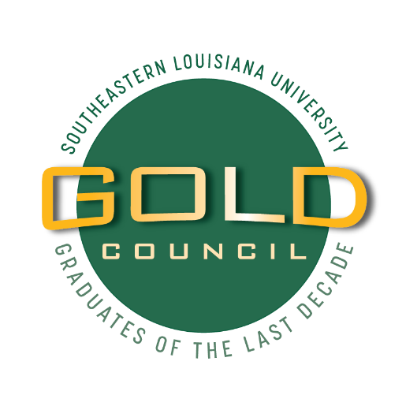

GOLD COUNCIL: 2024-2026

The GOLD Council (Graduates of the Last Decade) is a leadership organization dedicated to fostering and sustaining relationships with graduates from Southeastern of the last decade to keep them engaged and actively involved with the University. The Council advises the Office of Alumni Relations and the Alumni Association Board of Directors by developing programs and communications tailored to the newest alumni. The Council also acts to shepherd the development of volunteers and future leaders in ways that deepen their commitment to the University and prepare them for active alumni leadership roles. Members are elected from a body of former students who have graduated from Southeastern within the last ten years. They serve a two-year term with the option of serving two terms (total of 4 years).

MISSION:
The GOLD Council strives to promote the university’s mission, vision, and values to recent graduates, working to facilitate the transition of “active students” to “active alumni” through enhancement of Southeastern Alumni Center’s current communications, special events and forward moving goals.

The Council will work closely with Southeastern’s Office of Alumni Relations and the Alumni Association to create and engage in relevant and meaningful programs and services for young alumni, and to foster lifelong participation and philanthropic support.

GOALS:
- To provide opportunities and events for Young Alumni with programmatic emphasis on social, leadership, career and philanthropic development
- To foster a spirit of involvement and participation amongst Young Alumni
- To encourage engagement with constituencies across the University and the Alumni Association that best meet the needs of the Young Alumni population.

OBJECTIVES:
- Provide valuable perspectives, feedback and advice on prospective young alumni engagement initiatives
- Identify outstanding young alumni that can be featured in Alumni News and used for recruiting purposes for the University
- Promote the benefits of staying connected through a life-long association with Southeastern
- Promote the use of Southeastern Connect online portal
- Assist young alumni in maintaining/developing social and professional networks
- Assist Southeastern Alumni Relations to leverage industry connections and build strategic partnerships
- Explore and identify possible mentorship opportunities between young alumni and students
- Foster volunteerism and philanthropy from within the young alumni community
- Build alumni awareness among current students and welcome them into the community

2024-2025 TIMELINE:
July Summer Kick-Off Leadership Retreat
Aug Virtual Meeting
September General Meeting (In-person)
October Virtual Meeting; Alumni Awards Evening/Homecoming Activities
November General Meeting (In-person)
December Holiday Party
January Virtual Meeting
February General Meeting (In-person)
March Virtual Meeting
April General Meeting (In-person); Applications for new members open
May Virtual Meeting; Application deadline; Council members announced
June YAS (Young Alumni Social)

A GOLD Council Chairperson will serve as an Ex Officio, non-voting member of the Alumni Association Board of Directors. A Co-chair will be selected based on leadership abilities and serve as Chairperson the following year.

APPLICATION:
Membership is open to any young alumnus of Southeastern Louisiana University who:
1) Has graduated from Southeastern within a span of ten (10) years (currently 2014-2024)
2) Demonstrates leadership ability and/or potential
3) Possesses an infectious Southeastern spirit
4) Has completed the GOLD Council application; and
5) Given or pledged an active-level donation to an Alumni Fund (minimum $50) for the year in which the GOLD Council application is submitted, as well as their elected term years.

The office of Alumni Relations will review and select a slate of candidates for membership. Candidates will be chosen from a variety of ages and graduation years within this demographic, with as much diversity as possible. Members will be announced in May.

MEMBER RESPONSIBILITIES AND EXPECTATIONS:
As official volunteers of the Alumni Association, GOLD Council members will uphold several expectations including:
- Miss no more than three meetings (virtual or in-person) per calendar year (member is responsible for costs associated with attending meetings in Hammond)
- Attend the Summer Leadership Retreat (member is responsible for costs associated with attending meetings in Hammond)
- Assist with the planning, peer-to-peer marketing, and execution of Council-organized events and activities
- Represent the Council and the Alumni Association at local chapter events
- Serve as “Social Media Ambassadors” and share Southeastern Alumni’s messaging across social media channels and the Southeastern Connect platform
- Assist in the identification and recruitment of new volunteers and encourage participation in programming
- Support the University annually by making a $50 gift to the Alumni Association

REASONS TO SERVE:
- Professional networking: Connect with other recent grads in your community
- Personal friendships: Meet Southeastern alumni you might not have known while in school
- Voice of Young Alumni: Serve as an advisor to Alumni Relations and provide feedback and ideas to help shape the future of the alumni program
- University support: Almost all of us received some type of aid while attending Southeastern, so now pay it forward to future Lions!

BENEFITS:
- Increased value of your Southeastern degree well beyond graduation
- Be considered an influencer and role model to your peers
- Recognition at local Alumni chapter events
- Recognition on Alumni Association website
- Featured on Alumni’s social media channels

